**111 REFERRALS**

111 will email details of any patient they refer to us. We have dedicated email accounts to receive these emails…

**CRH referrals** will go to [CRH111Referrals@cht.nhs.uk](mailto:CRH111Referrals@cht.nhs.uk) **HRI referrals** will go to [HRI111Referrals@cht.nhs.uk](mailto:HRI111Referrals@cht.nhs.uk)

**TO ACCESS 111 REFERRAL EMAIL ACCOUNTS**

1. In **Webmail 365**, click on your **initials in the top right** of the screen. Select **Open another Mailbox**
2. **Type CRH111 or HRI111** (as appropriate for site you’re at), select the account then click **Open**

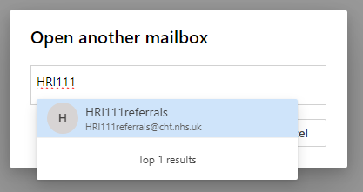 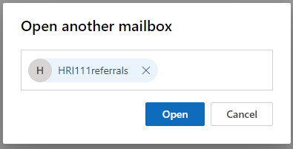

1. The 111 Referrals mail account opens in a separate window. You can switch between your own emails, the A&E Reception group emails and the 111 Referrals emails as and when you need to by clicking on the appropriate tab.

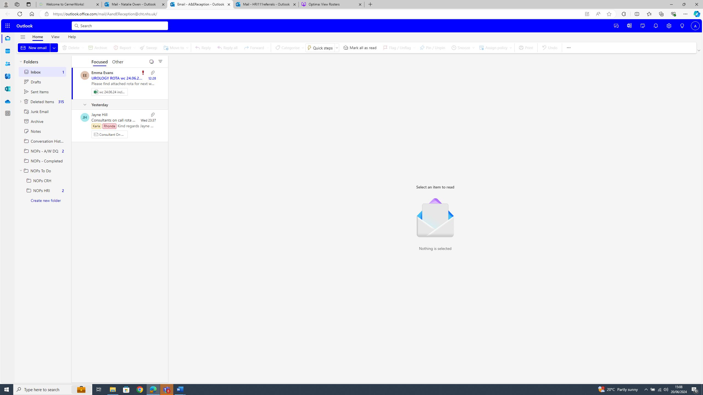

**TO ACTION A 111 REFERRAL**

1. **Open the 111 Referrals email account** for the site you are at
2. Type the **patient’s name** or the **111 reference** (Patient should have been given this) into the **Search box**
3. **Preview the PDF attachment** on the referral email**,** to **view the patient details and 111 Triage notes**
4. **Copy** the **NHS number** from the PDF
5. **Book patient in** as normal, **pasting the NHS number** into the Patient Search in First Net
6. If unable to find using NHS number (patients new to CHFT) search by Surname, Forename, Gender and DOB instead
7. Select **NHS Telephone or Internet Advice** as the Referral Source when booking in
8. **Click anywhere on the 111 PDF,** do **Ctrl A** to select All**,** then **Ctrl C** to Copy
9. **Open the patient record** in First Net and **add a clinical note** with the subject ‘**111 Triage’**
10. **Paste the 111 Triage notes** into the clinical note in First Net.
11. Check the notes you have pasted are for the correct patient.
12. Click **Sign** when finished and close the patient record.
13. Put **‘111 Referral – see notes’** into the **Comments box** for the patient on the Emergency Department screen
14. **Close the PDF** and move the referral email into the **‘Attended’ folder**
15. **Regularly check emails** in the 111 Referrals inboxes – **moving them to Attended or Did Not Attend as appropriate.** If a patient has not attended within 24 hours of referral being sent, move it to the Did Not Attend folder.