AMENDING BOOKING IN OR PATIENT DETAILS
If you need to change any of the details that have been entered during the booking in process…
1) Click onto the ED Registration tab then click once on the name of the patient to highlight them.  Select the Revision ED full patient registration tool bar button (it looks like a yellow pencil)  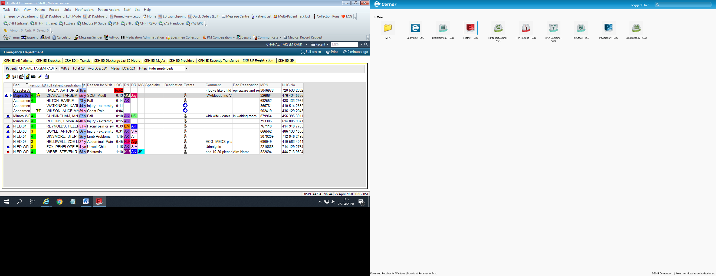 | 2) The Full Patient Registration conversation will open.  Navigate to the section that requires amending, alter details accordingly and click OK. Click OK again.

If you need to change any patient details (contact number, address, GP, NOK etc)…
If the patient is currently in ED follow instructions above
If patient is not currently in ED…
1) Select ‘Access Management Office’ from the Toolbar  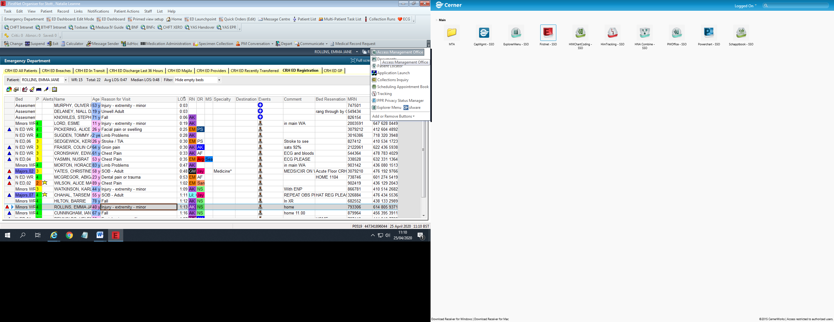 | 2) Select ‘Conversation’ on the left hand panel then double click on ‘Person Correction-Manager’.  Find the patient using the Search window then click OK.  Navigate to the section you need, amend details accordingly and click OK.

