**ED GP DISCHARGE LETTERS & ED ATTENDANCE SLIPS**

**ATTENDANCE SLIPS**

If a patient requires **proof of their attendance** in ED, please fill out and hospital stamp an **ED** **Attendance Slip**

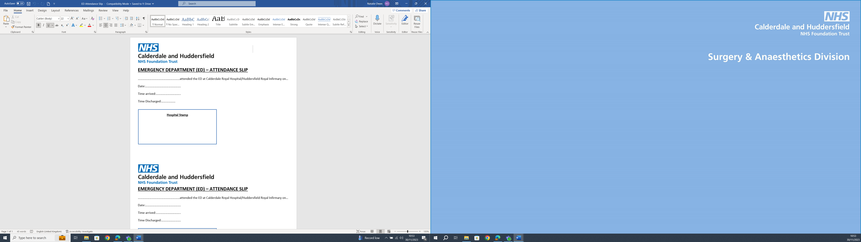

**ED GP DISCHARGE LETTERS**

***If a patient requires a copy of their Discharge Letter, ask them to contact their GP the following day to obtain a copy from them.*** Discharge details are often completed by the Doctor after the patient has left department. A discharge letter printed for the patient before they leave may be incomplete and inaccurate.

**SENDING ED GP DISCHARGE LETTER TO GP SURGERY**

**1)** Open patient record, click **Documentation**, click once on **Emergency Department GP Letter** for the date that the patient was discharged on. A preview of the letter will display on the right.

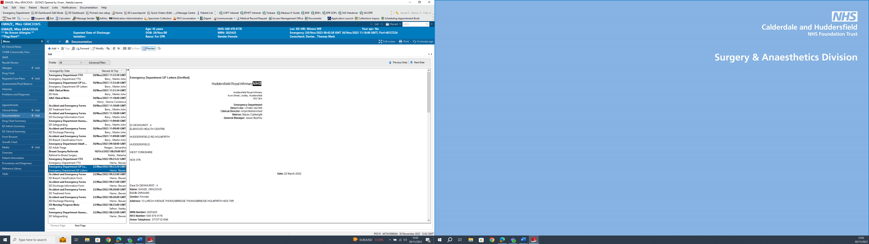

**5)** Click the **Printer** icon in the top right of the screen and collect letter from printer

**6)** **Scan the letter and send to yourself**. Copy of letter will come to your email inbox.

**7)** Forward email to the GP surgery. It must be an **NHS secure email address**