**CREATE TEMPLATES IN WEBMAIL 365**

1. Open a **new email** and click on Apps icon on the banner above. If you have the Classic ribbon banner it will look like this….

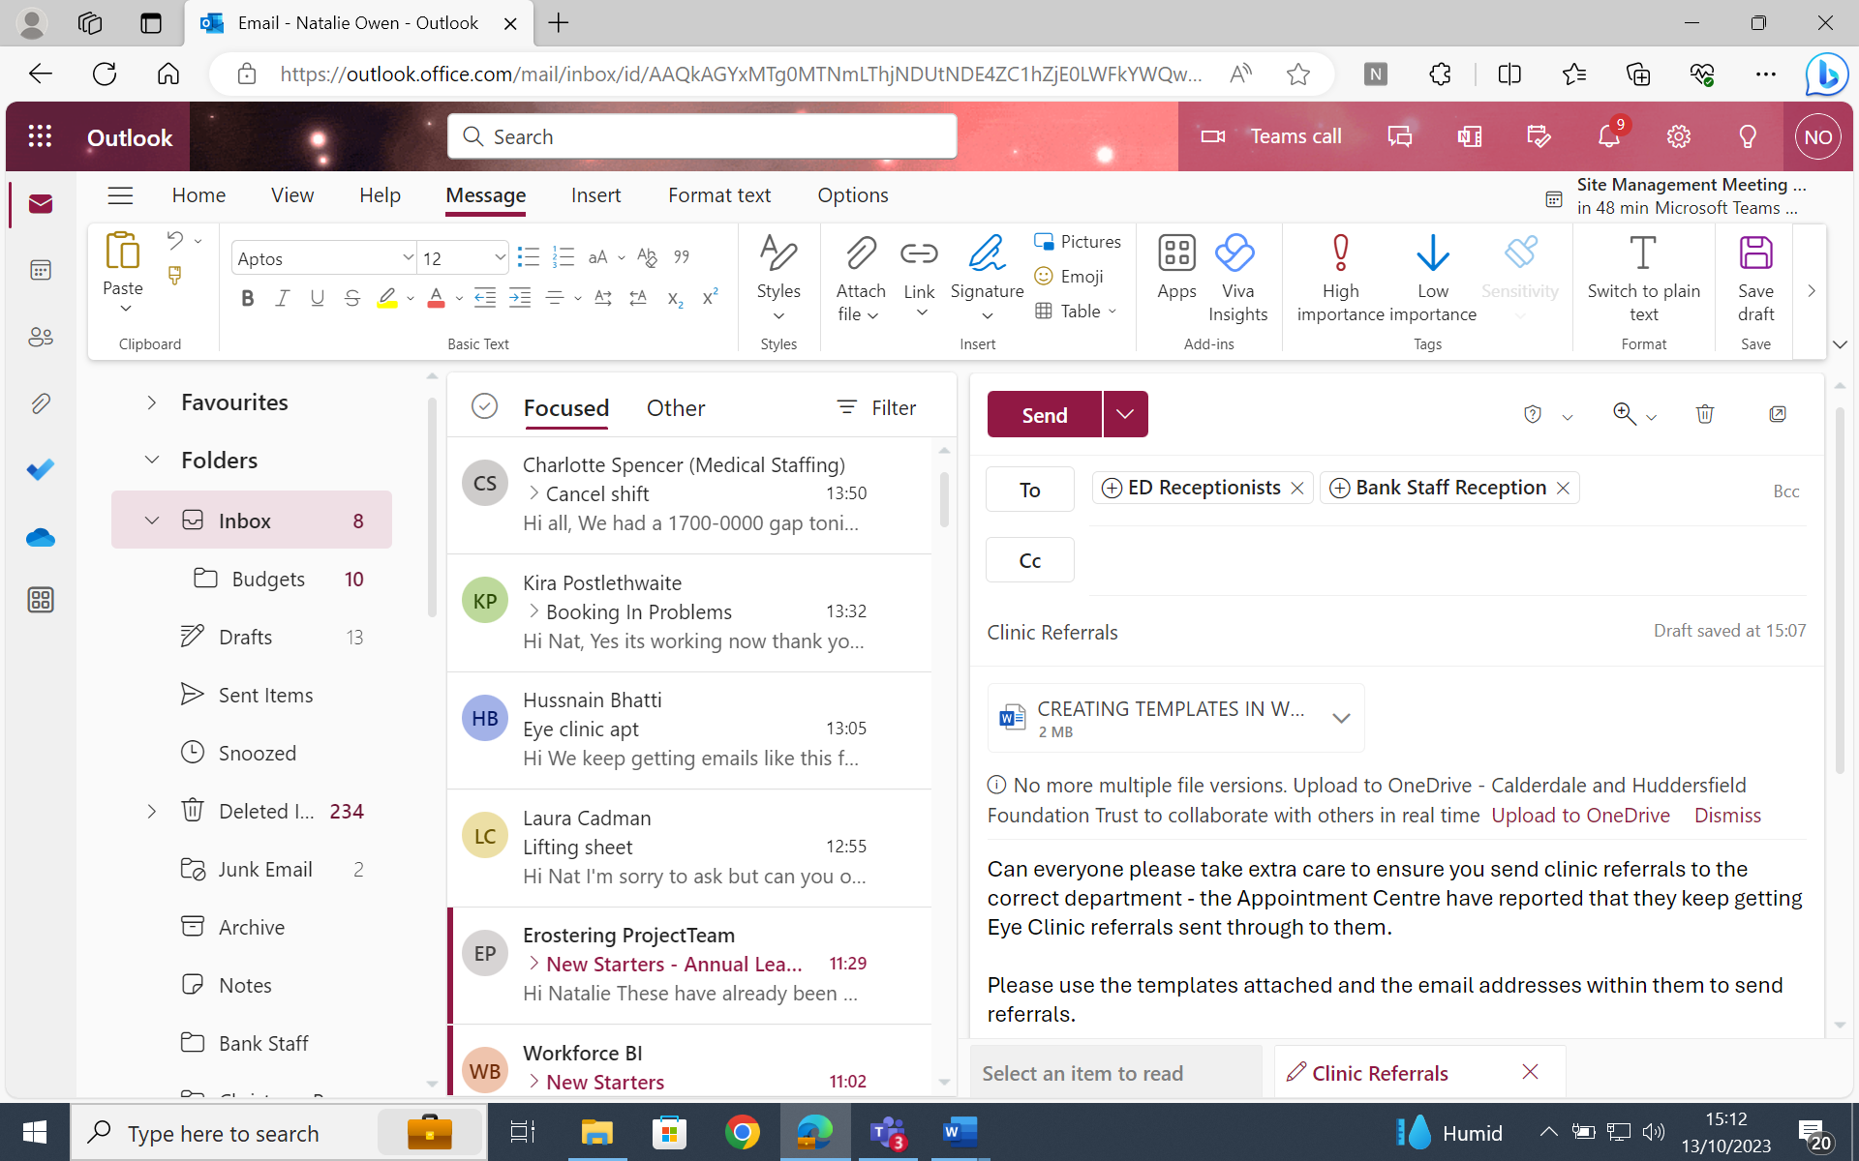

If you have the simplified ribbon banner it will look like this…

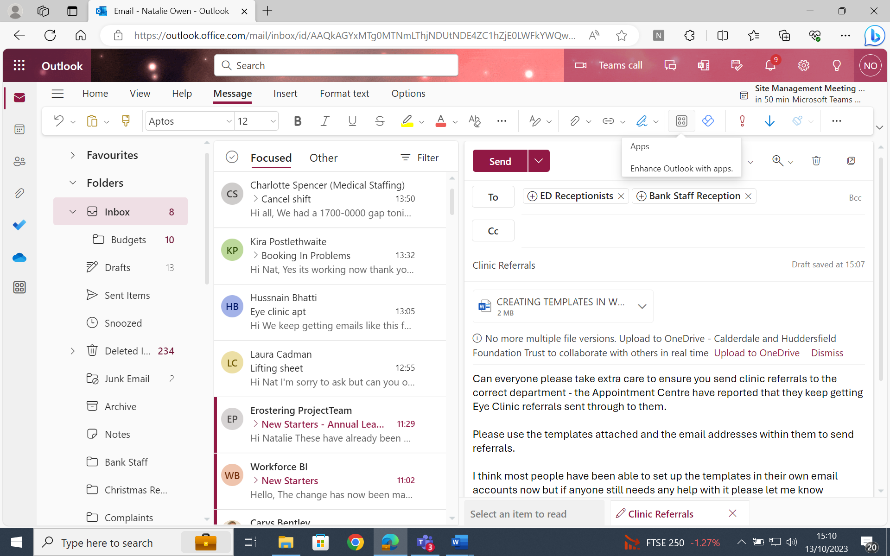

**NB** – If you want to switch from Classic to Simplified ribbon or vice versa, click the small arrow on the far right of the ribbon then select the version you want.

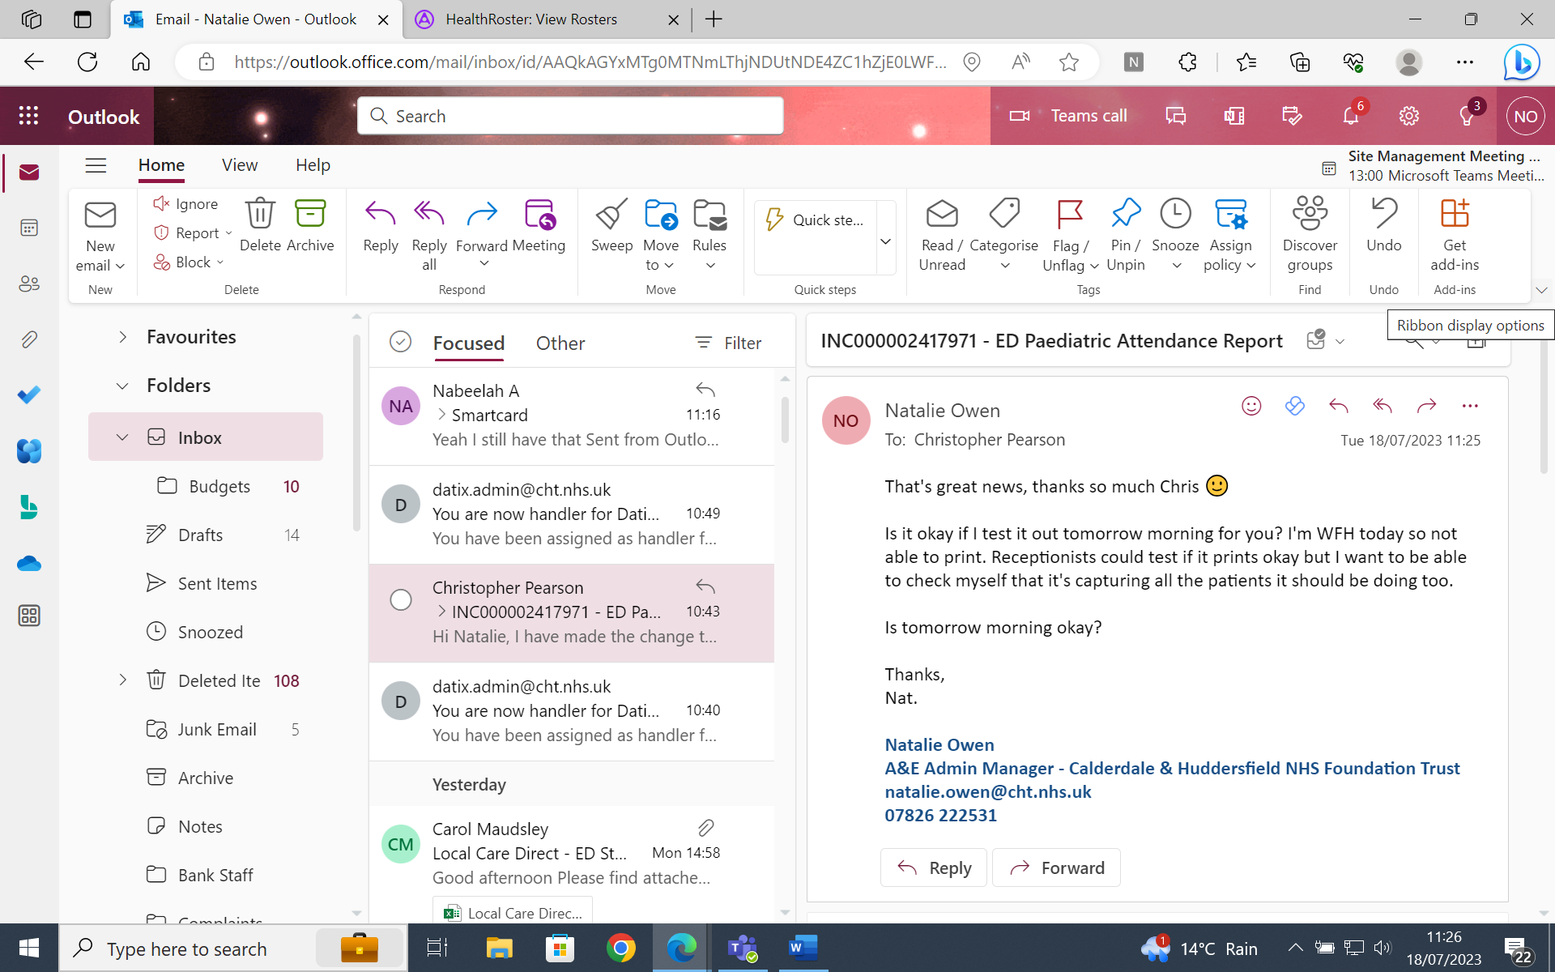

1. Click on **My Templates**
2. Click on **+ Template**
3. Enter a **Title** for the template (Fracture Clinic, Eye Clinic, Failed Spine Sync etc)
4. **Copy** appropriate template text from **Reception Email Templates** doc and paste it into box provided. Alternatively, you can free type the template text into the box. Click **Save**

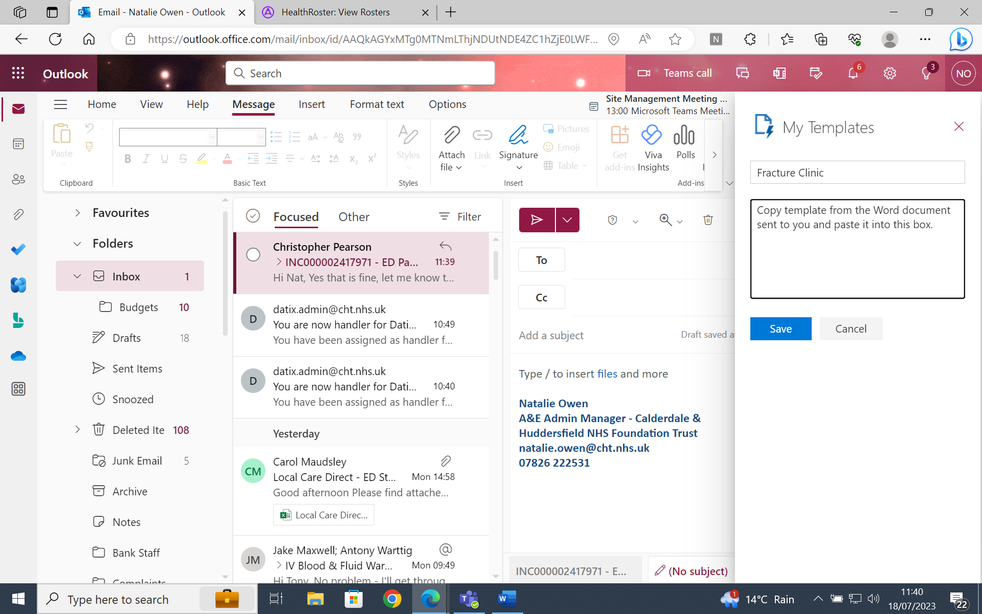

1. **Repeat the process for each of the templates** listed in the **Reception Email Templates** doc
2. Your templates will now be saved and available for you to use

**EDIT TEMPLATES**

* Go into **My Templates,** hover over template you want to edit, click on **Edit Template** icon 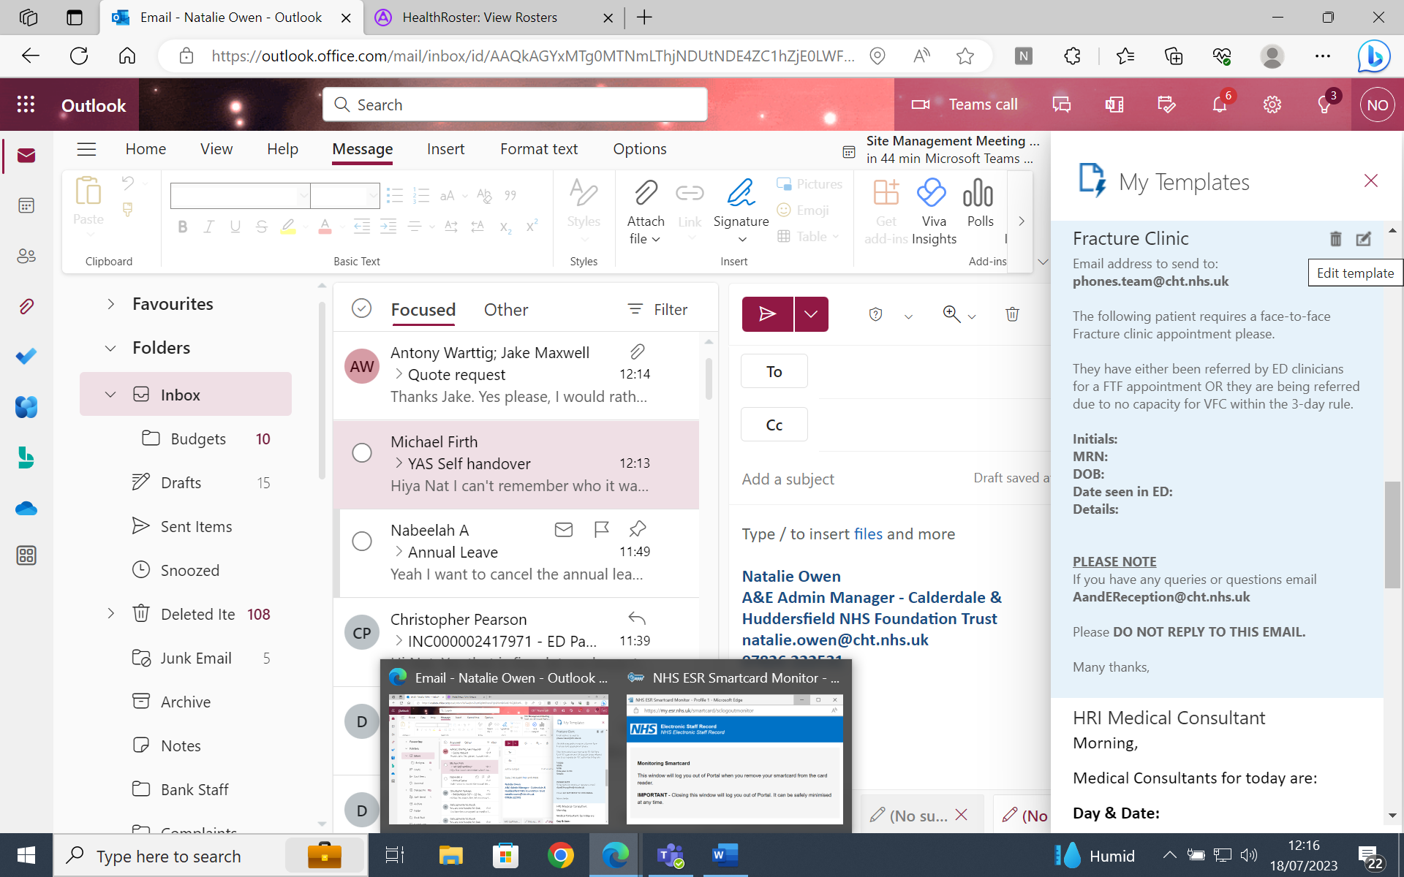
* Make your changes and click **Save**