**ORDERING WHEELCHAIRS AT HRI**

Open Capacity Management from the desktop

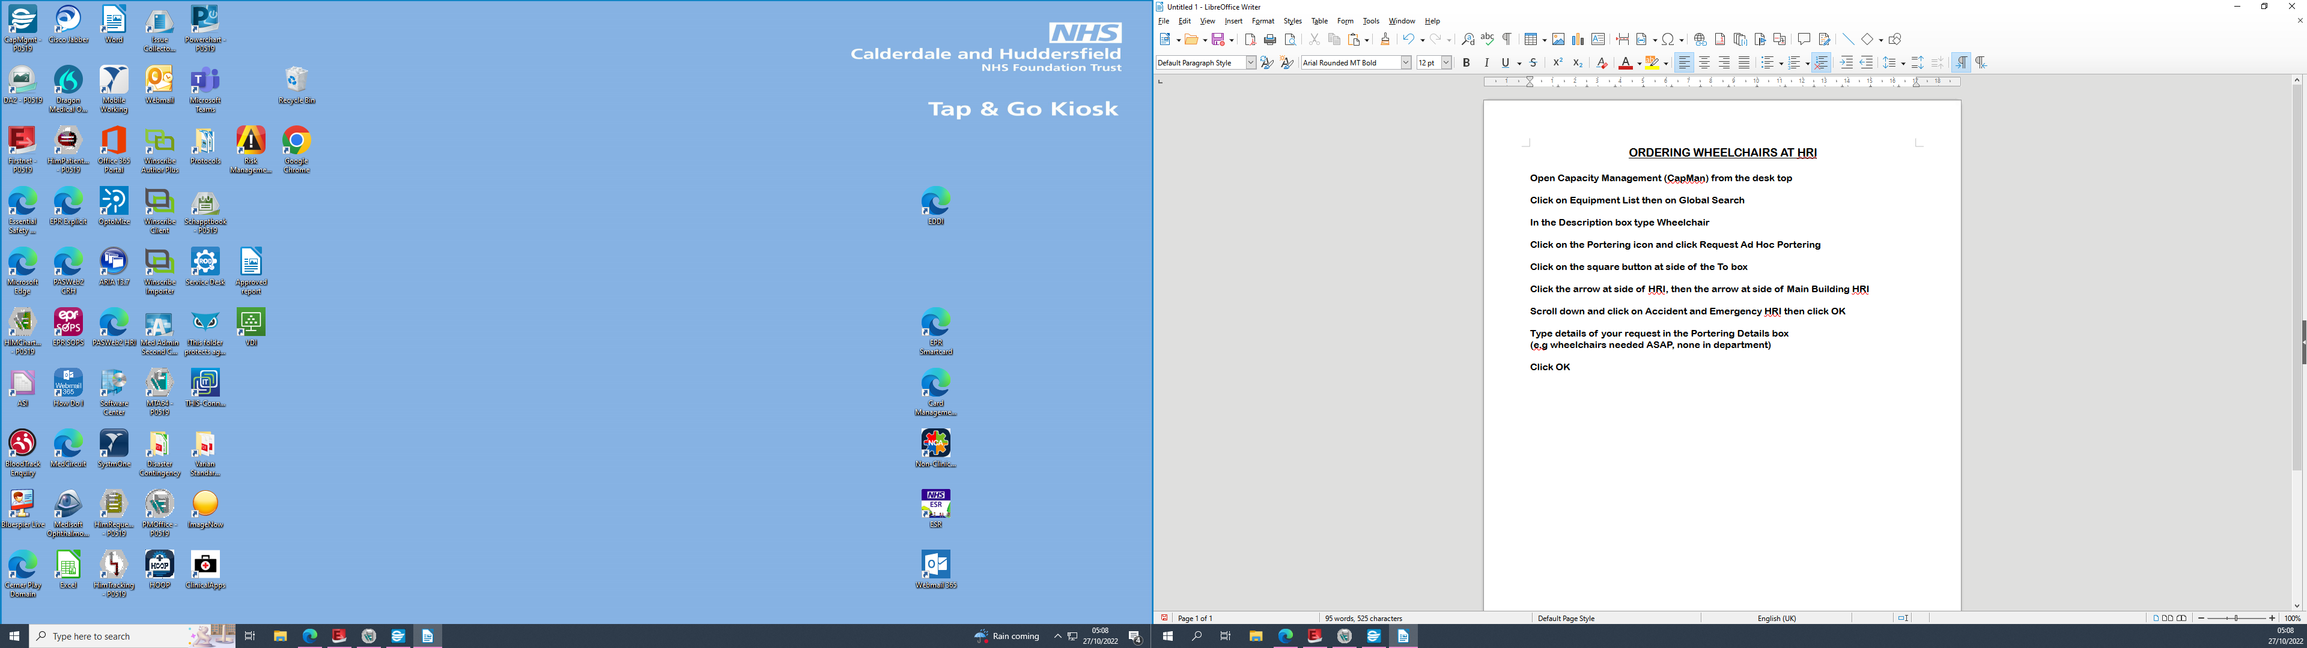

Click on Equipment List

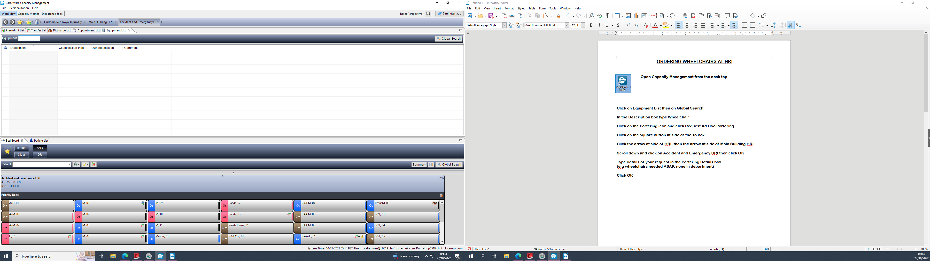

Click on Global Search on the right-hand side of the screen

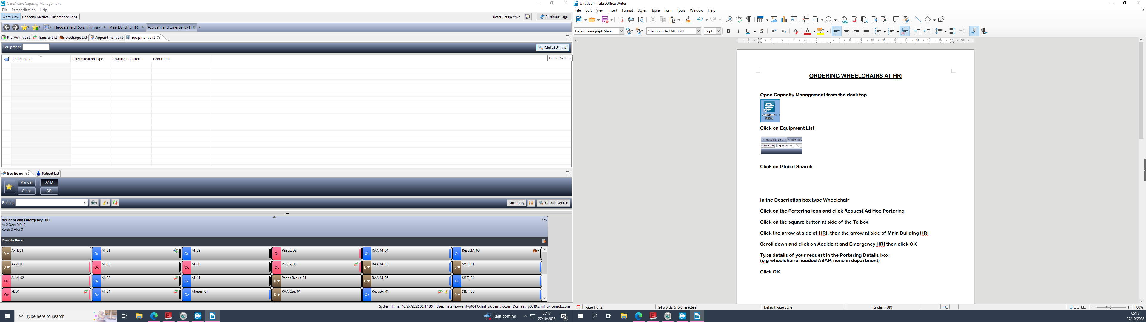

In the Description box type Wheelchair and click Search

Click on Wheelchair in the Description column, click on Portering icon above it, then click Request Ad Hoc Portering

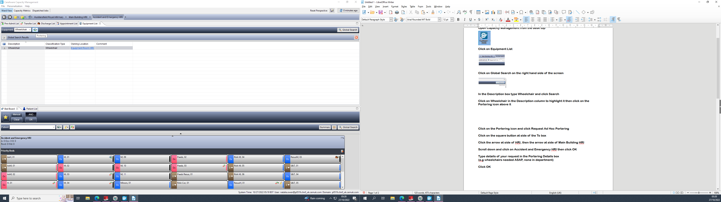

Click on the square button at side of the To box

Click the arrow at side of Huddersfield Royal Infirmary, then the arrow at side of Main Building HRI

Scroll down and click on Accident and Emergency HRI then click OK

Type details of your request in the Portering Details box (e.g wheelchairs needed ASAP, none in department) then click OK.

