**MANUALLY SYNCHRONISE A PATIENT RECORD WITH THE SPINE**

1. Open **Access Management Office**, double click **Add Person without Encounter** from the Conversation list
2. This will open a Patient Search window. Enter the patient’s **MRN** and click **Search**.
3. Once patient has been located **enter their** **Forename, Surname, Gender and DOB** into search fields and **remove the MRN**. Click **Search** again.

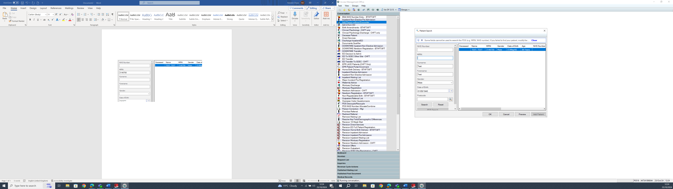

1. Click **PDS Search** to trigger a Spine search. Select the patient on the PDS Trace Results screen and click **Select**.

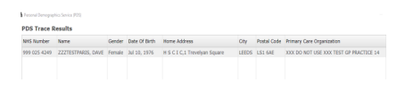

1. If you are presented with a **PDS Comparison Screen**, carefully select the correct details for the patient then click **Update**.

**NB** – The info you select at this point will be pushed onto the hospital and the GP records. Always take care to ensure you are selecting the correct details.

1. You will be returned to Add Patient without Encounter conversation. The **Spine sync has now been performed and updated information pulled through to the patient record**. Click **Cancel** (bottom right) to safely exit the Add Person without Encounter conversation.