**PRINTING ED PAEDIATRIC ATTENDANCE REPORTS**

***These must be done on Nights at CRH at any time AFTER Midnight***

1. Open **DA2 (Explorer Menu)**
2. Double click **Explorer Reports** then **Main Menu**, then **ED Reports**, then **ED Paediatric Attendance Report**
3. Click on printer icon next to ‘Output’ drop-down. Select **Printer**, then select **chftsecureprint** from the list, **OK**
4. Select **Calderdale and Huddersfield NHS Foundation Trust** from the Trust drop down menu
5. Enter **Reporting Period dates and times**:
6. The **Start date** and the **Finish date** must **BOTH** be the **day before** (the date your Night shift started)
7. The **Start time** must be **00:00** and the **Finish time** must be **23:59**

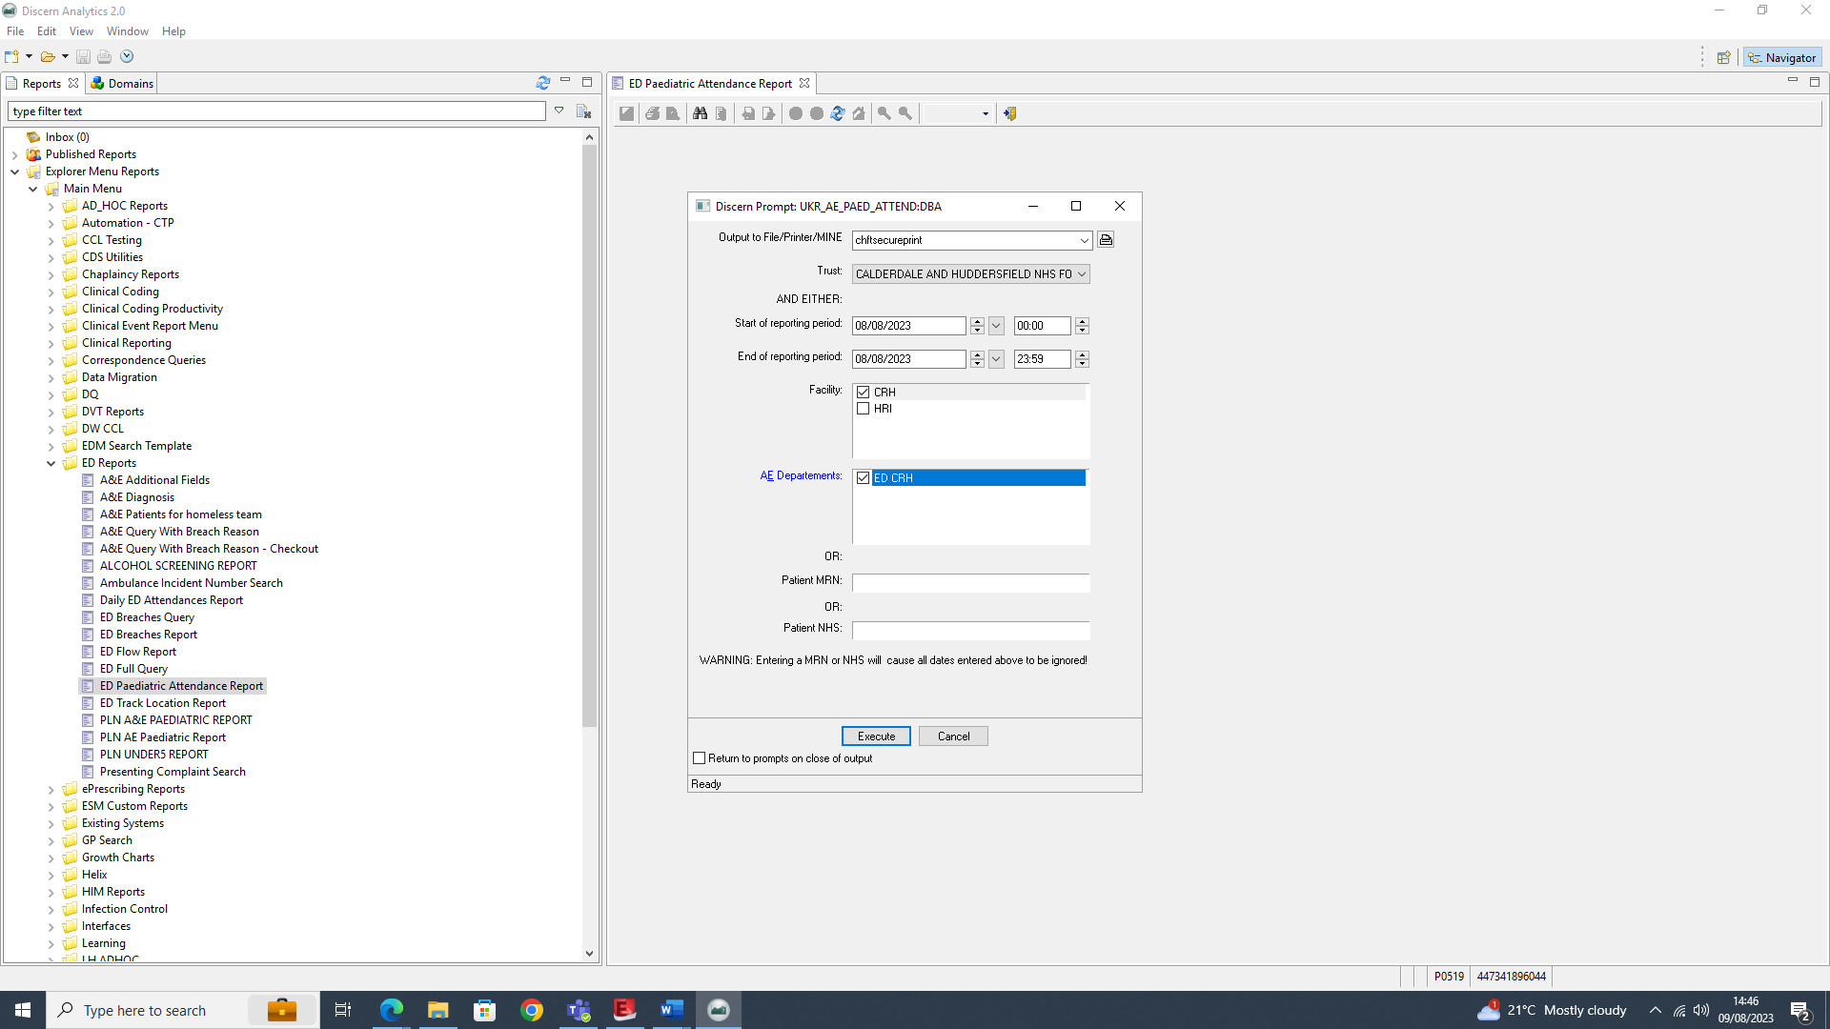

1. Select **CRH and HRI** for the Facility, then **ED CRH and ED HRI** as AE Department. Click **Execute**.
2. You’ll see the below messages whilst the report is being collated and then when the report is done…

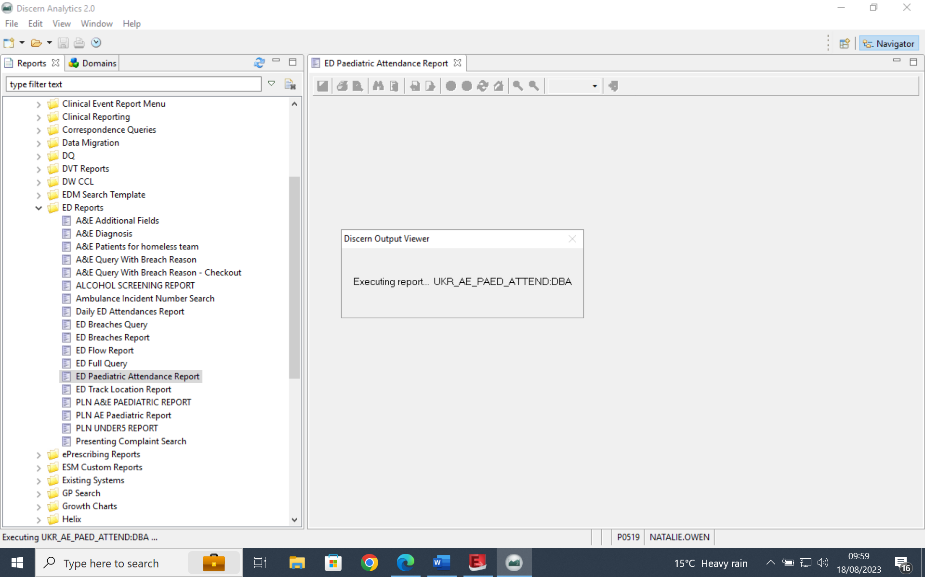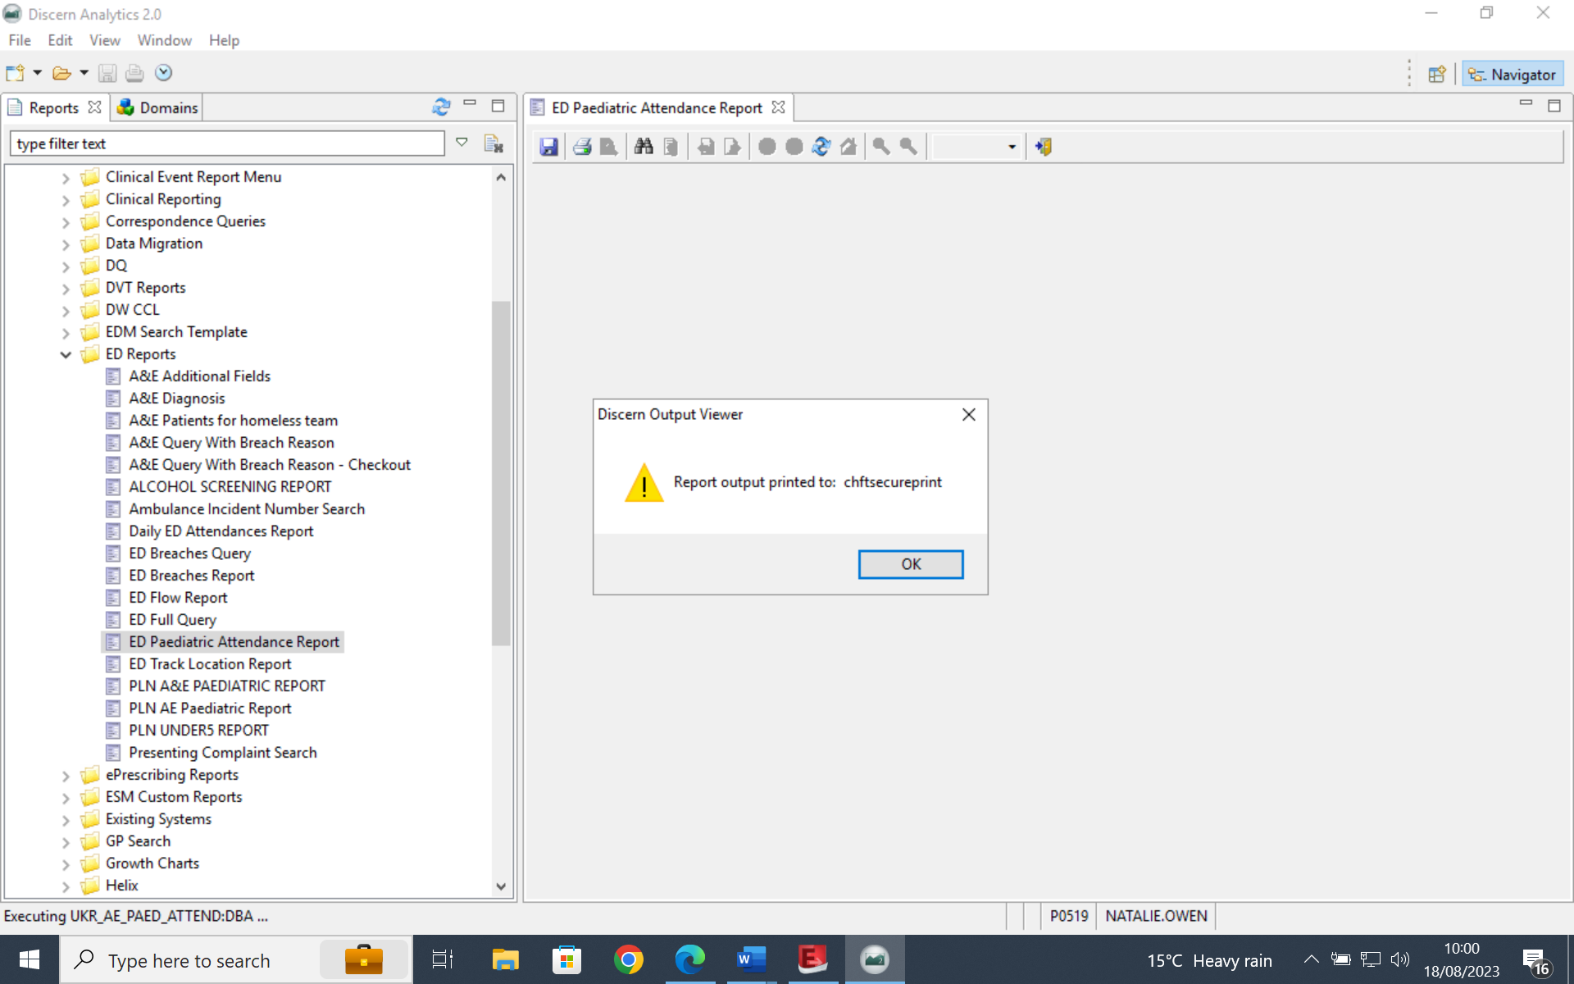

1. **Wait at least 10 minutes before collecting reports from the printer**. As it’s a large report there can be a small delay in all of it arriving at the printer.
2. Log onto the printer and select all documents to print and delete. Once done **Refresh your print list** to check that no further report documents have arrived to print. If they have, print and delete those too.
3. Put the printed reports into the Paeds Box for the Paeds team to collect the next morning.

**In the event that the reports cannot be printed:**

* Check that you have followed all steps in the User Guide correctly
* If all steps followed and still a problem report this via email to Natalie Owen and/or Tom Whittle
* Ask your colleague at HRI to run reports for you and send printed documents to CRH the next morning. Email [natalie.wood@cht.nhs.uk](mailto:natalie.wood@cht.nhs.uk) to make her aware of this.
* If both sites unable to print the reports - both sites must use the Manually Printing Paeds Letters User Guide to print the letters. HRI must then send their printed letters to CRH the next morning. Email [natalie.wood@cht.nhs.uk](mailto:natalie.wood@cht.nhs.uk) to make her aware of this.