**PATIENT ADDRESSES & CONTACT NUMBERS**

**ADDRESSES:**

**PATIENT HAS MOVED TO A NEW ADDRESS**

1. Select **New** to add the new address.
2. Click **Search for Address**. Enter **postcode**. Click on the **+ icon** to load addresses listed for that postcode.

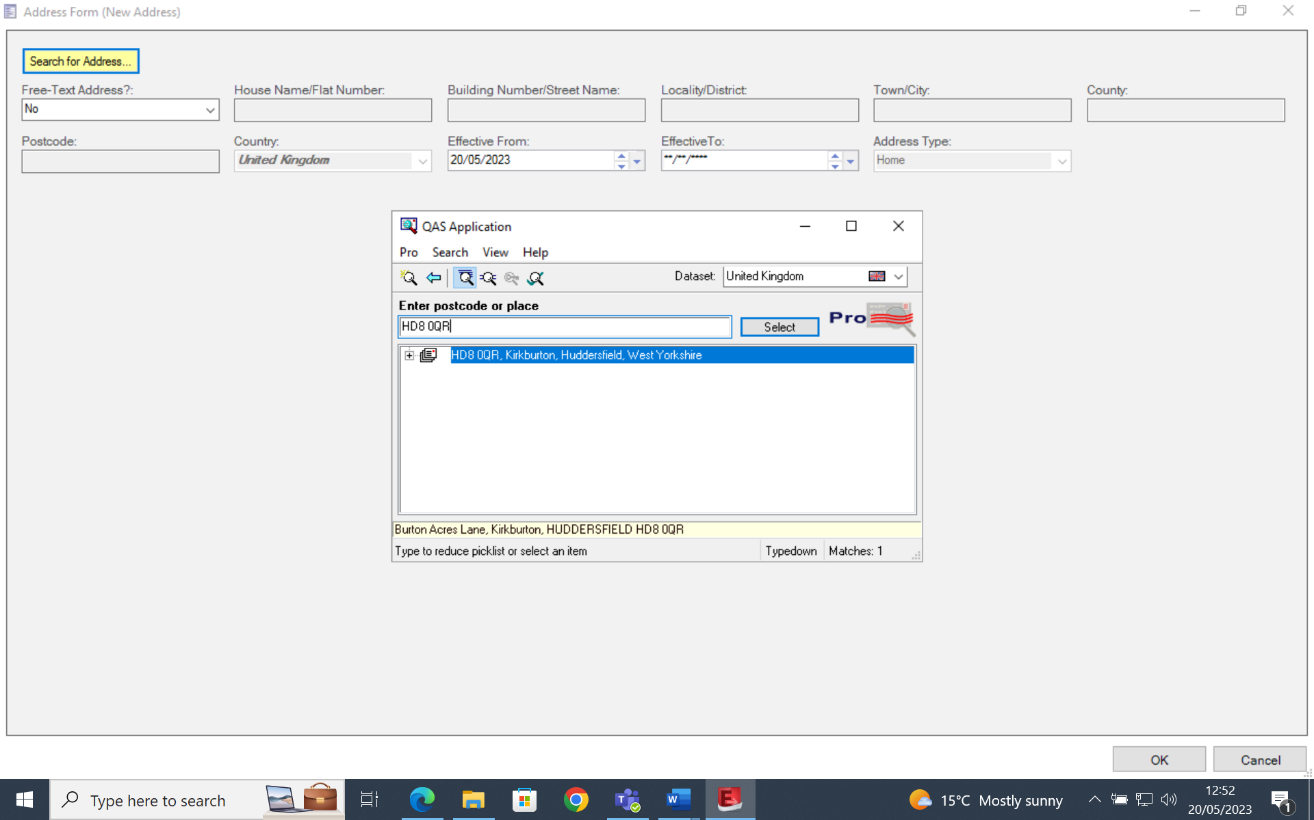

***NB*** *- If the patient doesn’t know their postcode, find it using* ***www.royalmail.com/find-a-postcode***

1. **Highlight the correct House number/name** & click **Select.** The selected address will be displayed.

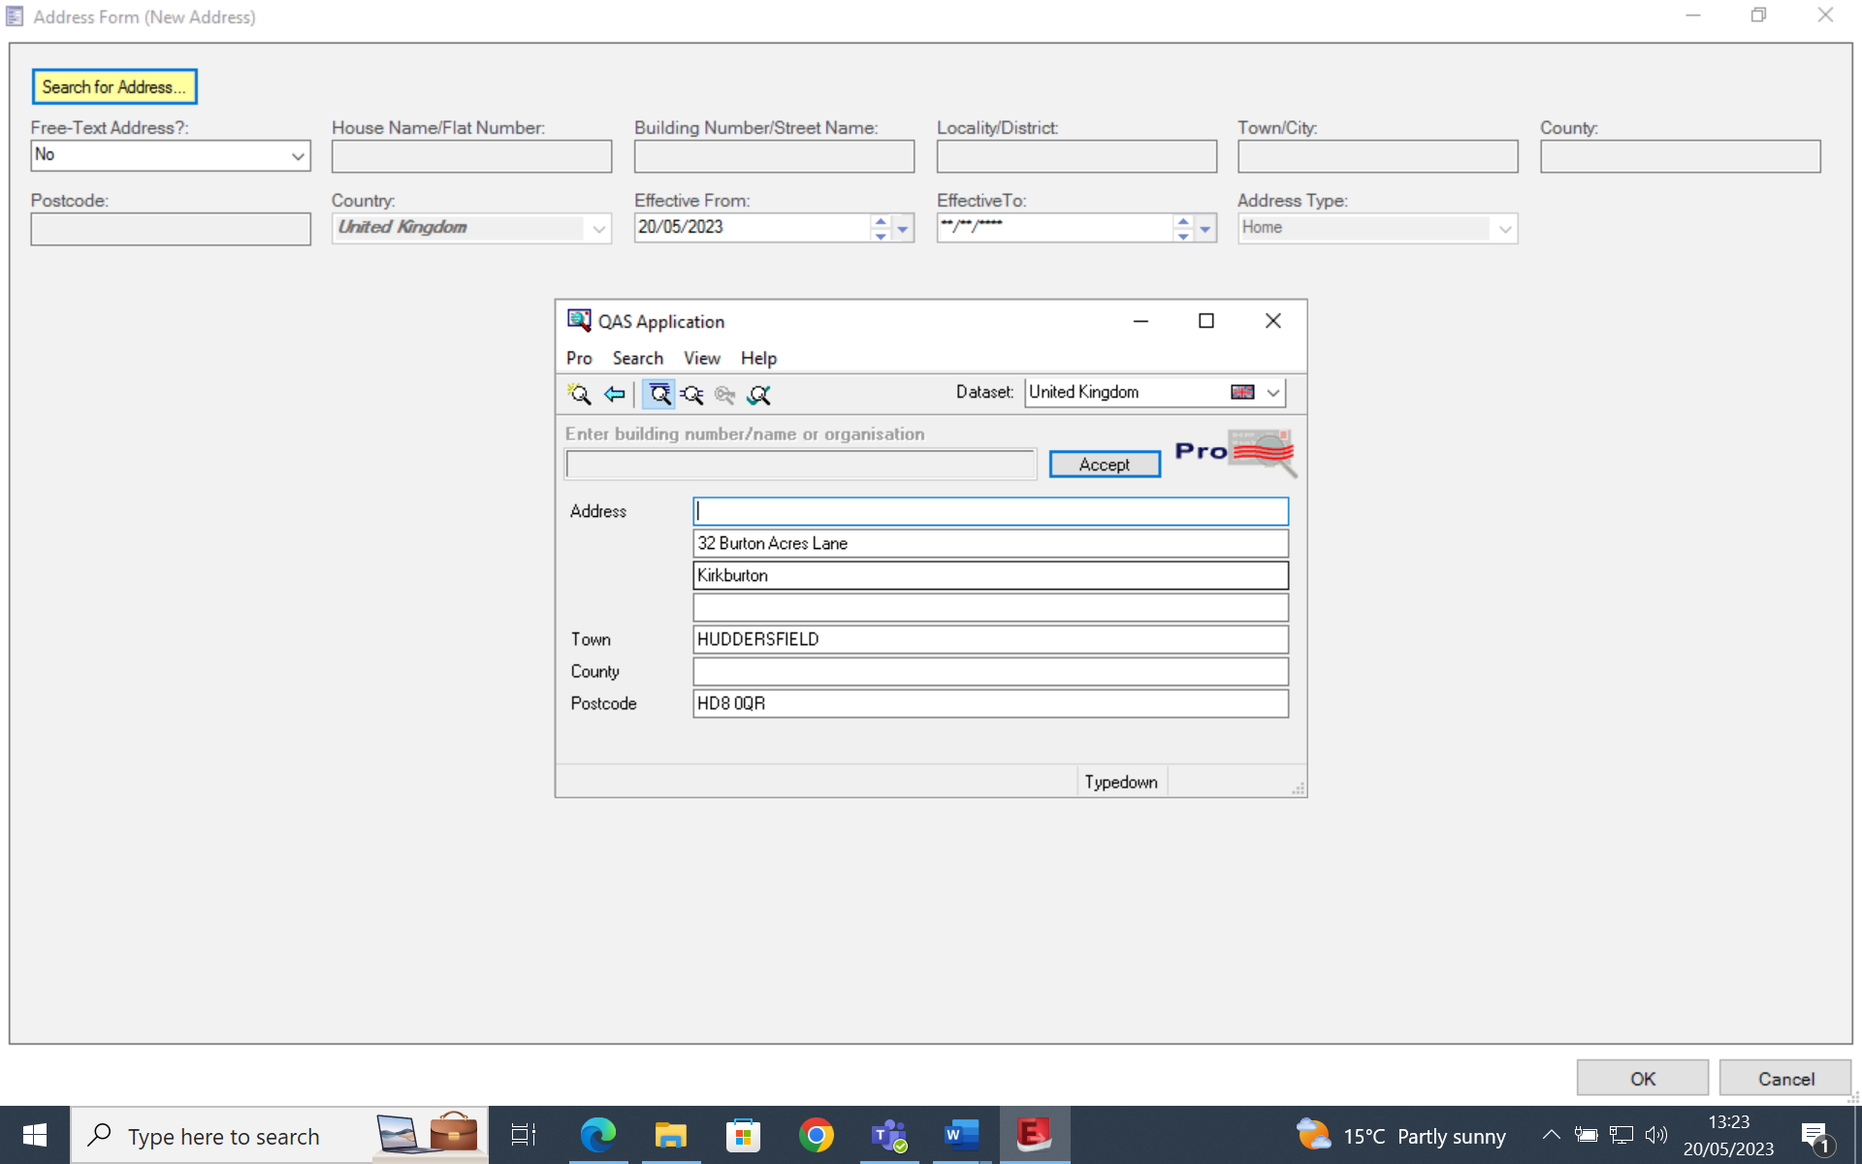

**DO NOT make changes to the format of the address.** Select **Accept, OK** and **OK** again.

**PATIENT ADDRESS IS RIGHT BUT IT IS INCORRECTLY FORMATTED**

Follow steps as above but click **Modify** rather than New in Step 1).

**PATIENT WITH NO FIXED ABODE**

**Select Yes** from the **No Fixed Abode** drop downmenuin the Address section. You do not need to add an address once this is selected.

**OVERSEAS VISITORS & UNKNOWN PATIENTS**

Please see individual SOPS which detail how to correctly enter their addresses.

**CONTACT NUMBERS:**

Telephone numbers must be saved into the correct field i.e Home number must be saved in the Home section, mobile number must be saved in the Mobile section.

Numbers must not be duplicated - e.g same number saved in Home section and Mobile section.

Duplicated numbers and numbers being stored in the wrong section cause Spine Sync failures and cause issues with the contact numbers pulling through to the patient record properly.

**If a patient record has the same contact number duplicated, delete it from any incorrect field leaving it saved just once and in the correct field.**