**PRINTING A WRISTBAND OR FACESHEET**

1. Click on ‘Documents’ on the Toolbar in First Net then click on Magnifying Glass icon
2. Enter the patient’s MRN and click Search
3. Click on the Emergency Department encounter listed below patients name and click OK

***FOR WRISTBAND:***

**a)** Click on CHFT Wristband Adult New and then click the printer icon

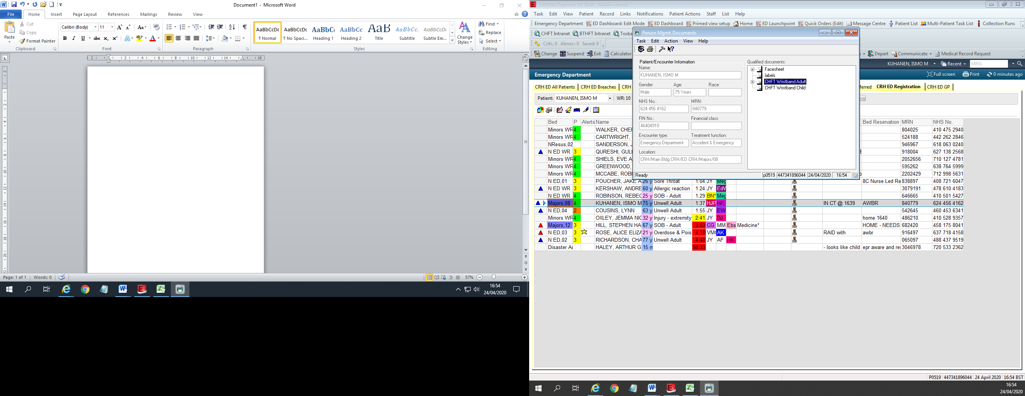

**b)** From the printer drop down list select the appropriate printer then click OK

wb_hri_edsdal2 wb_hri_edsd2 wb_hri_edsd1 wb_hri_edsdal1

WB_CRH_EDW WB_CRH_ED2 CHFTSecure Print CHFTSecure Mono

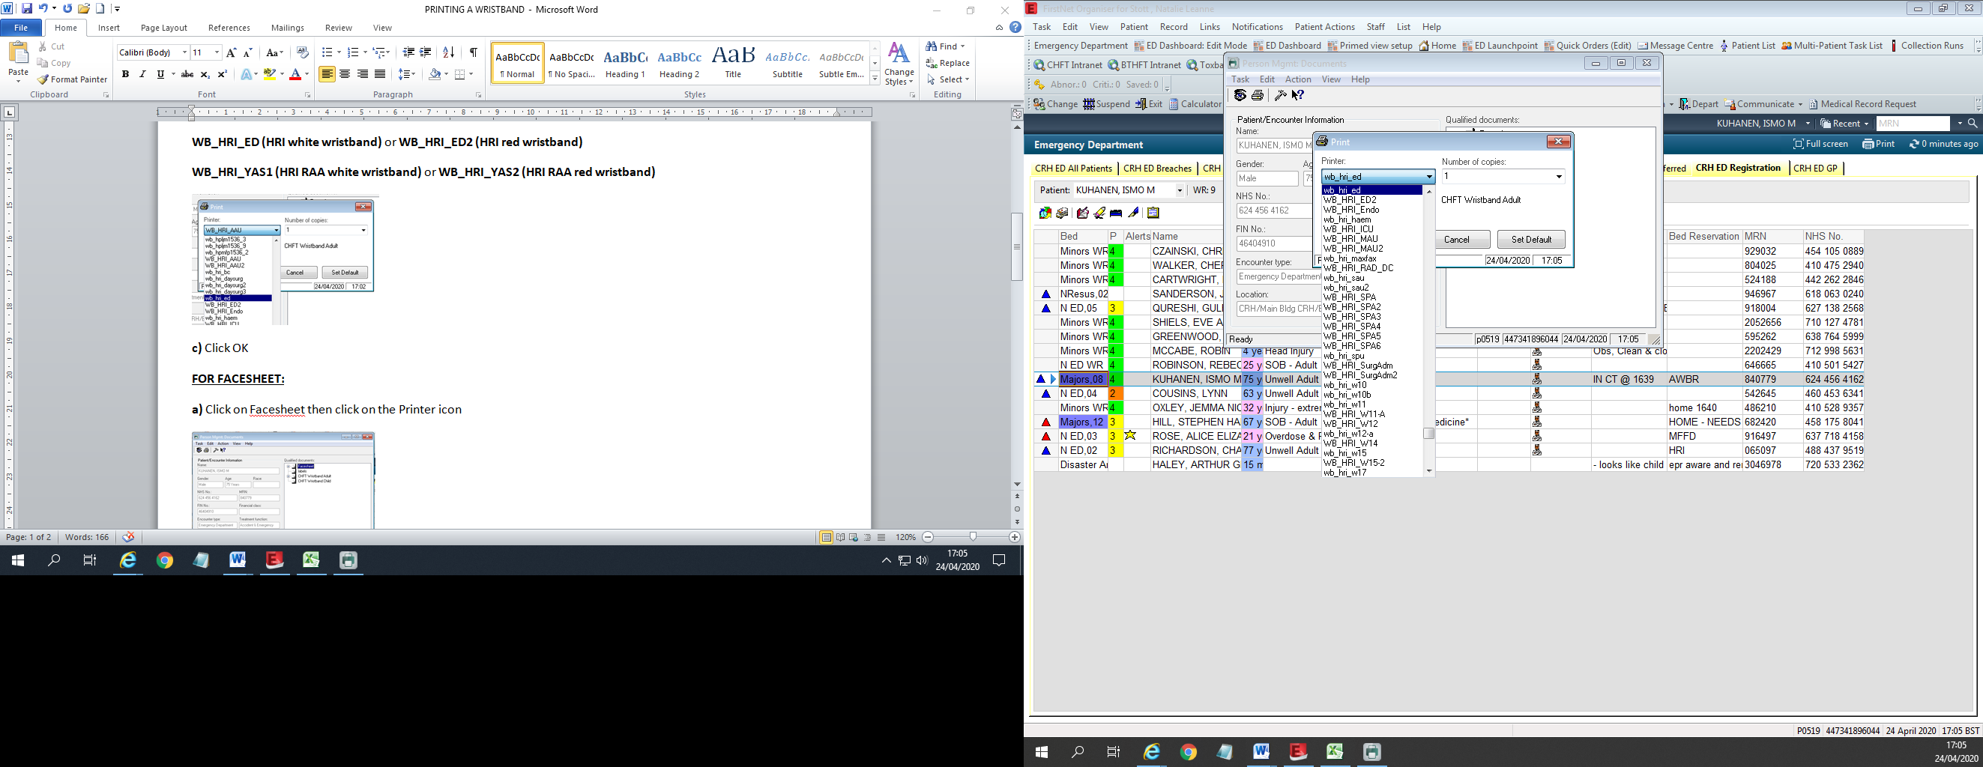

***FOR FACESHEET:***

**a)** Click on Facesheet then click on the Printer icon

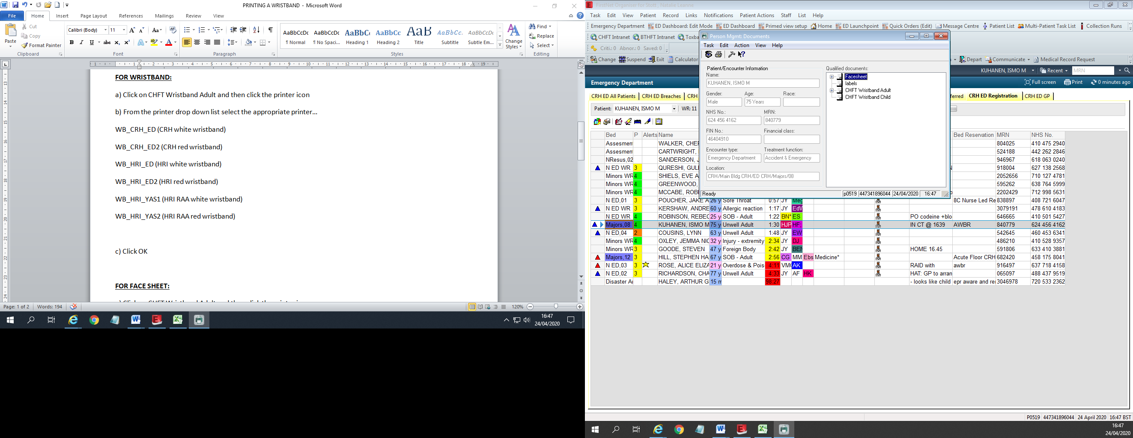

**b)** From the printer drop down list select ‘CHFTSecureMono’ then click OK

