**Spine Synchronisation work list – Knowledge Portal Plus (KP+) – Writeback Model – Feb 2024**

Model is to be found here accessed via KP+ icon on non clinical tools on desktop





In the Spine Synchs stream down the left handside



Double click on this model

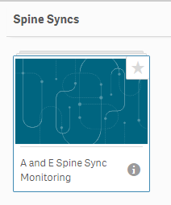

Double click on this (the only one in the public sheets currently) app

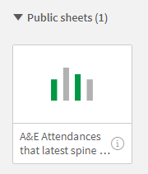

This produces this screen

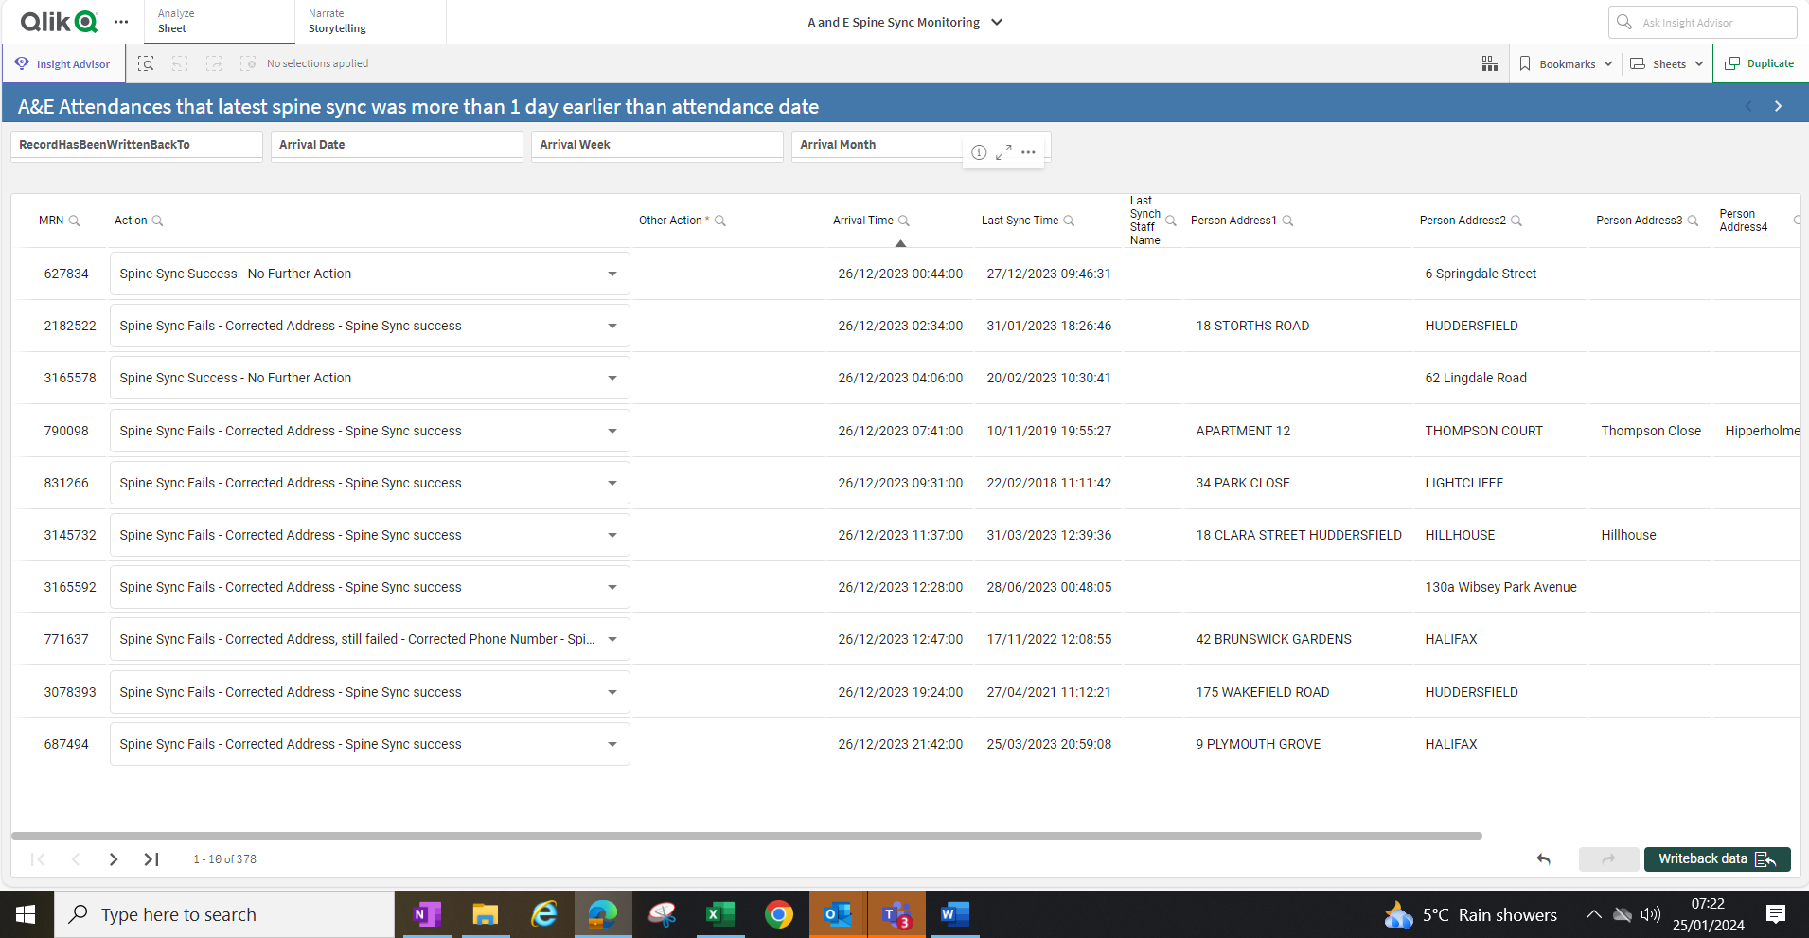

**Overview**

This is a list of all the a and e attendances that are believed to have only spine synced some 24 hours previous to their attendance or not synced at all.

The plan is for through the night A and E reception staff to be trained in how to audit each record, confirm or otherwise if the spine sync does fail, clean up the address in to the correct format using a standard approach, and then update the audit log on the KP+ writeback app accordingly.

Any attendances on this list that cannot be audited and resolved by the night staff will be picked up the Corporate Data Quality Team (Chris Bottomley, Andrew Speight, Salma Bibi).

It is believed that as the number of patients on EPR that have their address in the incorrect format and as a result don’t spine sync first time is reduced we shall see a reducing number to this audit list. i.e. More patients when they attend will spine sync on registration.

**Audit process**

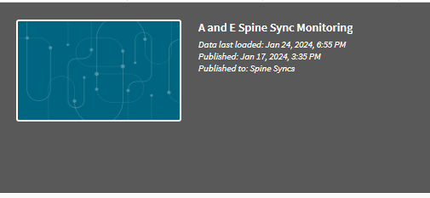

Before you start work it is important to note that data last loaded date and time as per above. If warehouse processes have worked accordingly then this date and time should be the previous day around 7pm (assuming you are working on this early morning and you haven’t already updated records using the **writeback** button – more on that later)

To access the latest list of attendances that require auditing

Click on this button



Select No

And then the tick

The list will now look like this

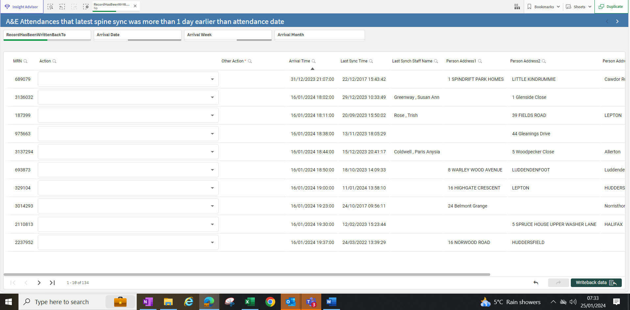

In this example there are 134 attendances to audit and work through

You use these buttons to move up and down the list 10 patients at a time or to get to the end or beginning of the list.



Click on this button



And then scroll down to choose the latest date to be audited.

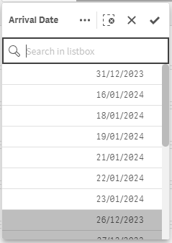If a date has had all attendances audited it will be greyed out.

Highlight a date by clicking on it (suggest the latest date) and then the tick again.

For the 23rd Jan 2024 there were 17 attendances to audit.

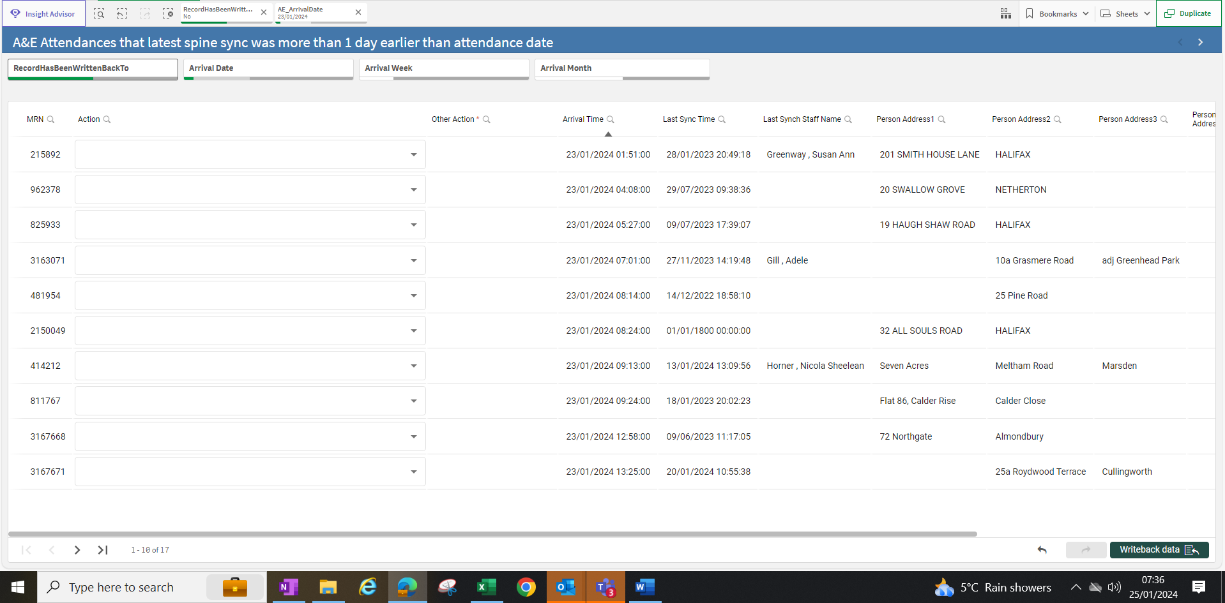

Some of these may already have been spine synced through the process already in place with the corporate data quality team where receptionists have emailed through that a spine sync has failed.

We are now ready to go through the correcting of the address process and successfully spine synchronising for each record.

Ensure you have your EPR smart card access and go into PMOffice by firstly clicking on

 And then clicking on 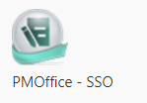

Then go to the conversation area – we firstly want to confirm that the patient we are auditing does fail the spine sync process (it maybe that it has been cleaned up by the process where receptionists report failed synchs to the Corporate Data Quality team).

From the KP+ model you have open, hover over the MRN for the record you are auditing, right click and click on “copy cell value”.

Then in PMOffice

Click on “Direct Services” conversation- this connects us to the spine 

Click in the MRN box of the patient search tab and right click and paste in the MRN

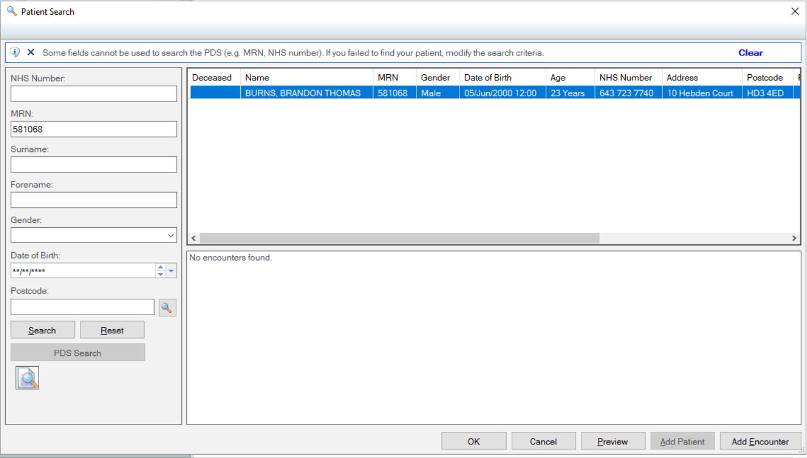

Then click on Add Encounter

In the facility name box type “hud” and press carriage return, this highlights “Huddersfield Royal Infirmary” and now click on “OK”

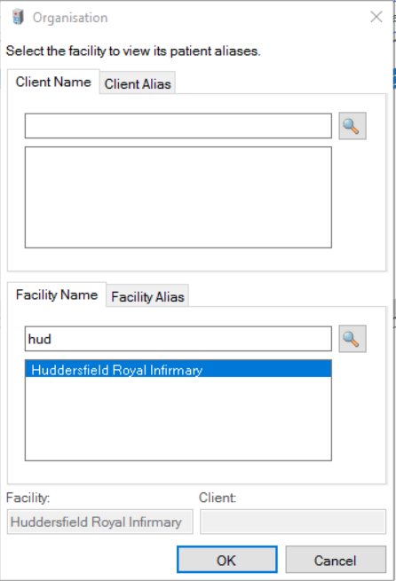

The Personal Demographics Service (PDS) review differences screen may present. Follow the usual process of making notes of the most recent information that wants to be kept. Choose the appropriate radio button and click on update.

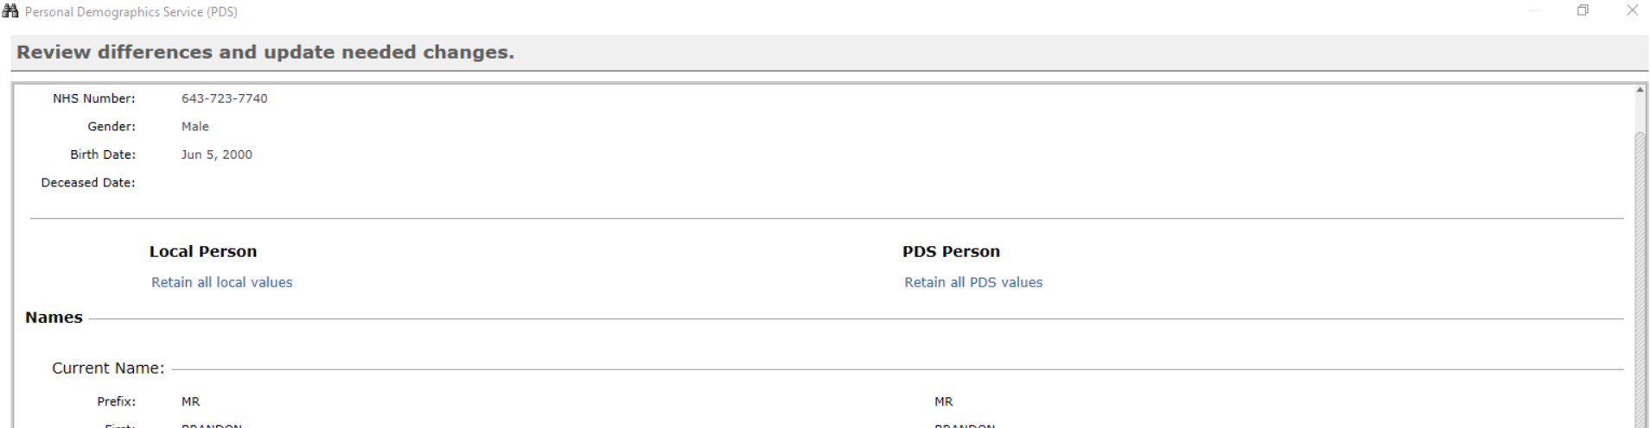

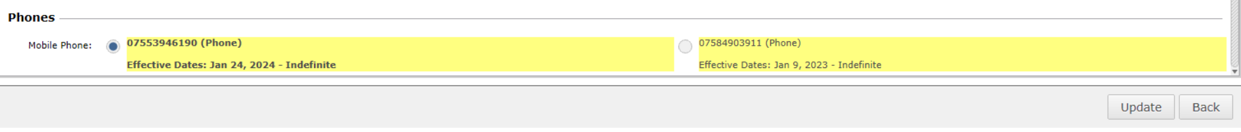

**1 If the record spine syncs fine (no error message)** at the Direct Services screen click on the Cancel button bottom right so no additional encounter is created.

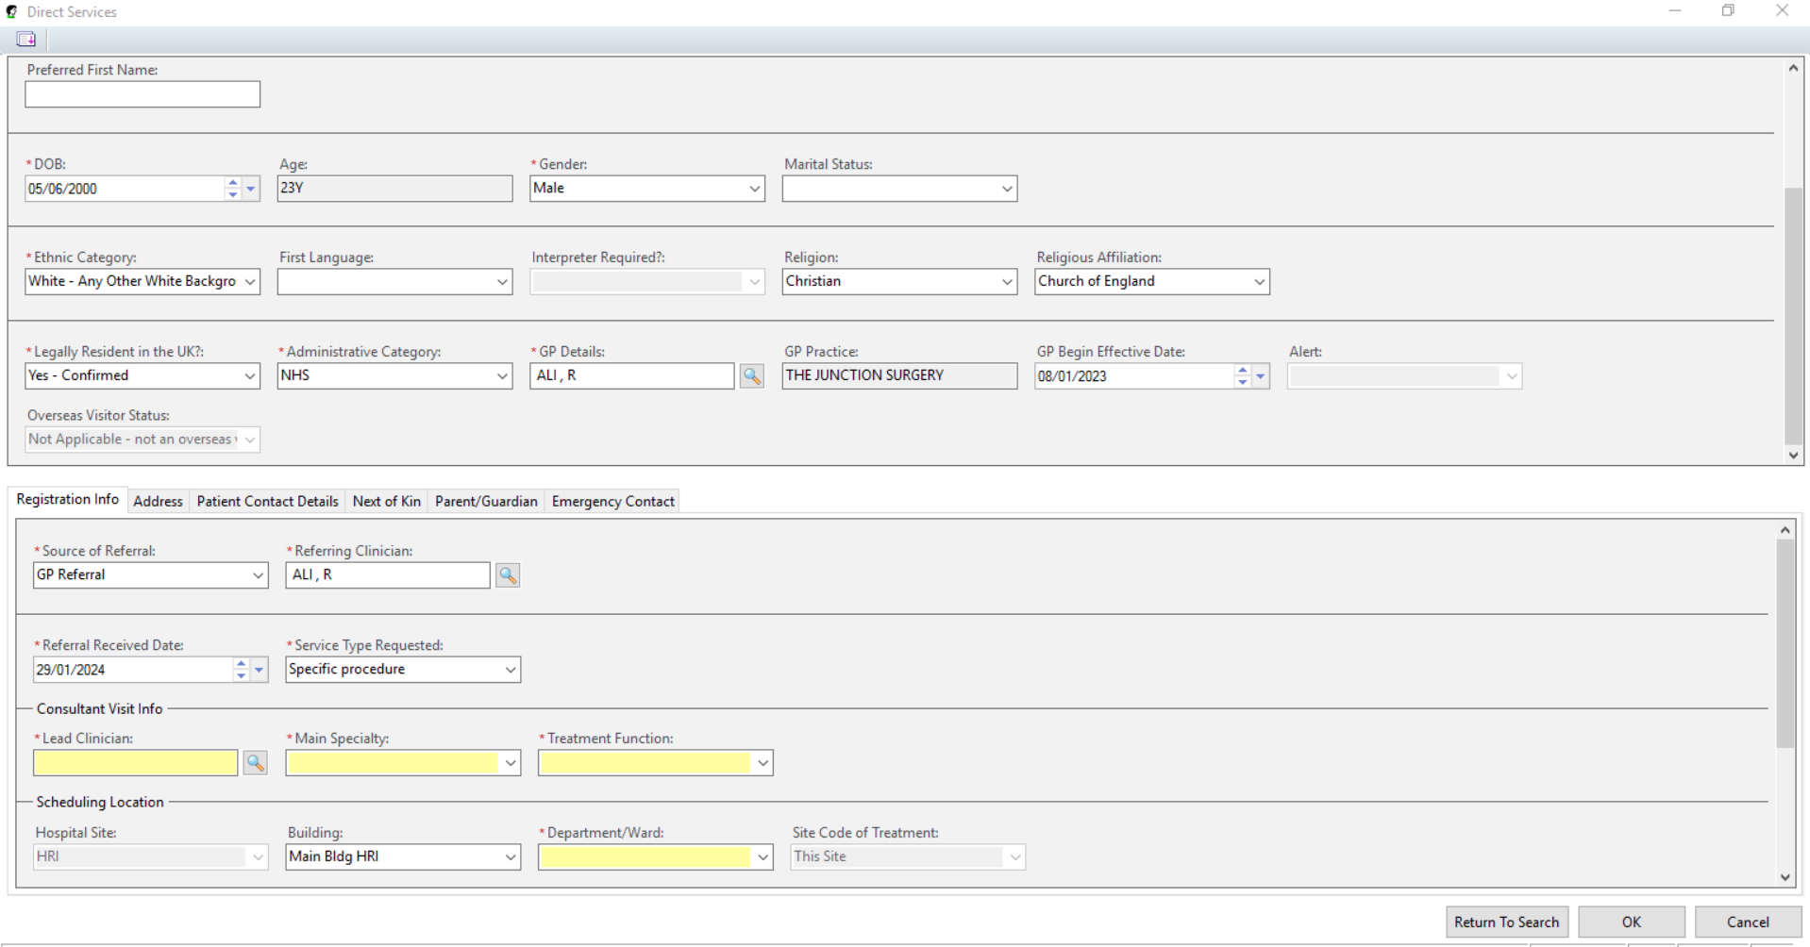

Then at the next screen click on “Yes” to confirm we are cancelling the conversation

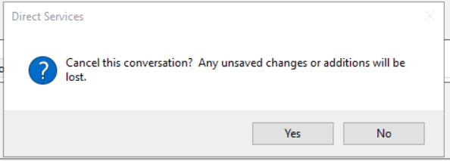

Go to the KP+ Writeback model and click against the patient you are auditing on the dropdown and choose the option “Spine Sync Success – No Further Action”

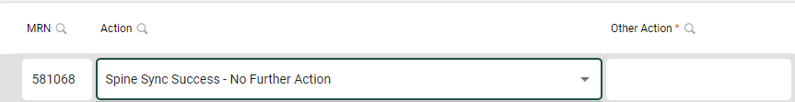

Then Click on this button on the bottom right to save the audit information.



**2 If the record spine syncs fails (error message) and you get a PDS Notification error message**

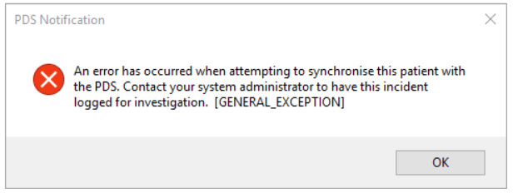

Click on **Ok**

And then again click on the **Cancel** button bottom right to cancel the conversation and again choose Yes to confirm your action (as per bottom of page 6).

Now the process is to update the address of the patient on EPR so it is in the correct format to hopefully achieve a successful spine sync. This uses the QAS facility via the “Person Correction Manager” conversation.

In PMOffice double click on the “Person Correction Manager” conversation 

Enter the MRN in the MRN box and click on Search. When happy have the correct patient click on OK.

In the Facility Name box type “**hud**” then click on “return”, this brings up Huddersfield Royal Infirmary highlighted then click on “OK”.

Click on the “Address” tab

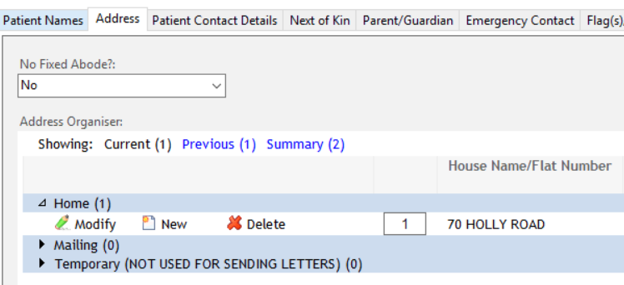

Click on Modify

Click on Search for Address (the yellow button)



Type in the postcode of the address

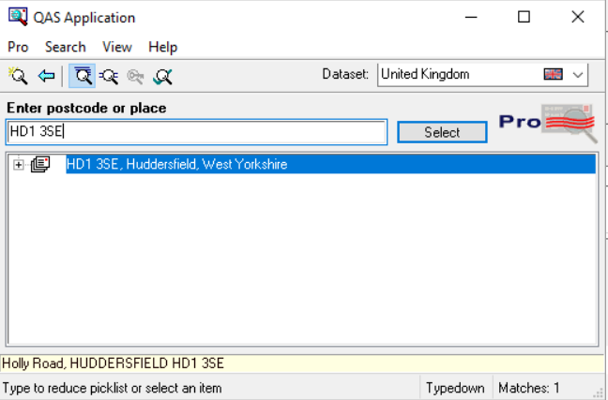

Click on the + and find the correct address

Double click on it – note how the address format changes (no more Huddersfield Huddersfield for example or use of the first address field) and the click on the “Accept” button.

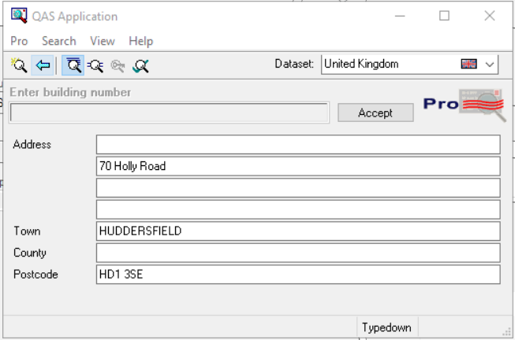

This puts the address into EPR in the correct format for spine syncing.

The click on OK to see the address in correct format on the actual record.

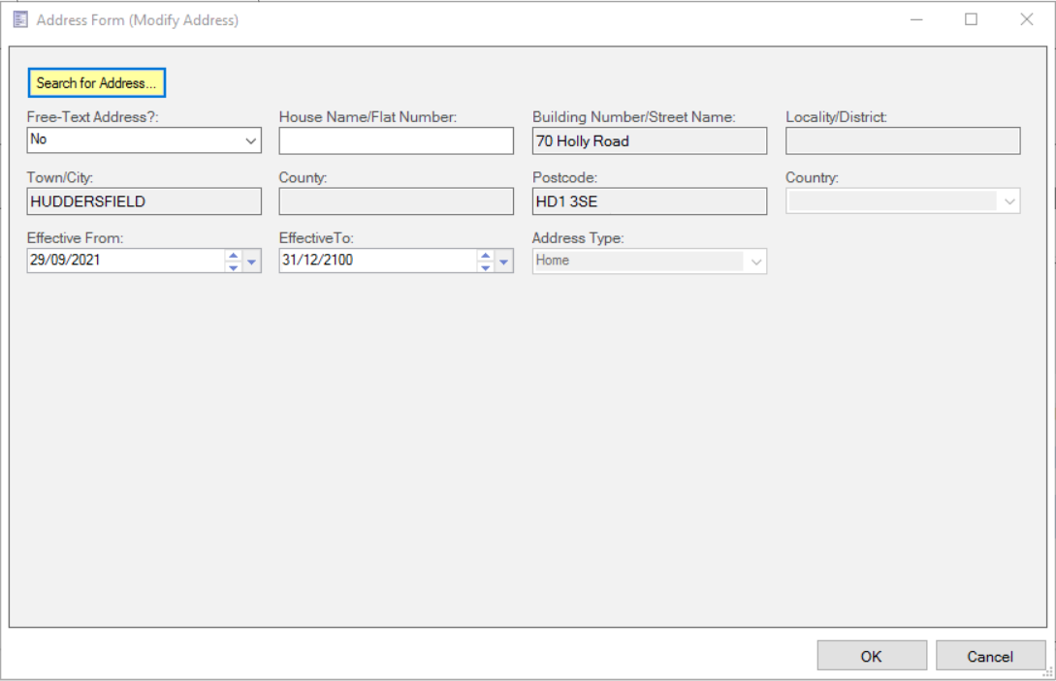

Then click on OK again to save this modification.

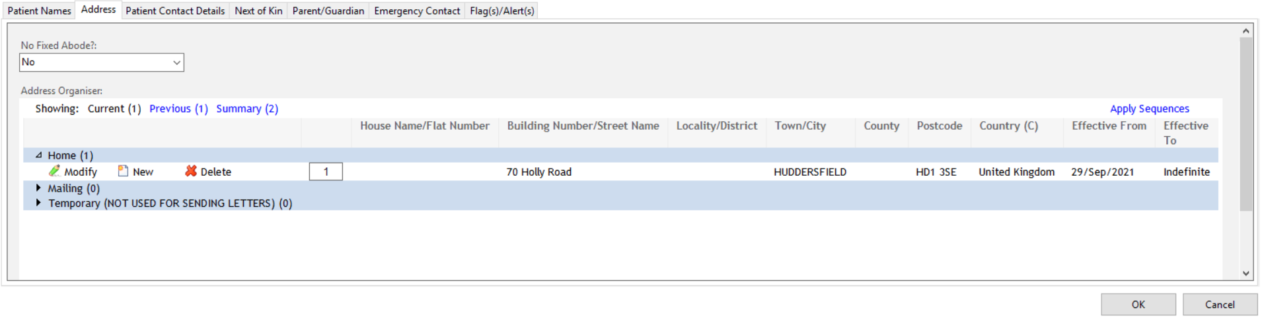

Now repeat the “Direct Services” routine as per pages 5 to 6 in these notes and as you work through this same process at the end more than likely the spine sync will be a success.

Assuming it is, then be sure to choose **Cancel** at the Direct Services screen and the **Yes** to confirm this action (as per page 6) and

in the KP+ Writeback Model

choose the “**Spine Sync fails – Corrected Address – Spine Sync Success**” option



And then click on the Writeback Data button bottom right of screen.



If the sync fails again (it is like an issue with the phone numbers) then

Choose the “other Please Specify” option and type some appropriate message in the free text Other option Box.

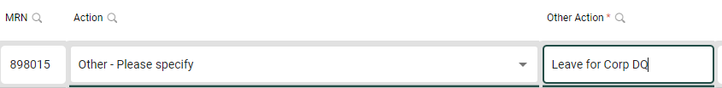

Again be sure to click the “Writeback” button to save the audit.

Corporate DQ will look at those that aren’t resolved and depending on how well this work goes we will look to tackle phone numbers and more advanced corrections in the future.

One step at a time.

There is a strong belief that incorrect address formats is the main reason for failed spine synchronisations. Every one that is audited and successfully spine synced will hopefully result in fewer failed spine syncs in A and E in the future on the desk live with the patient – correct updates for the patient from the spine and letters going to the correct GP etc.

Good Luck and Thank You

Points of contact for feedback, concerns, ideas etc

Natalie Owen (of course), Salma Bibi, Chris Bottomley and Julian Bates (all will pick up messages via the THIS Data Quality and Standards email address where you email failed spine syncs currently)

|  |  |
| --- | --- |
| [The Health Informatics Service](https://gbr01.safelinks.protection.outlook.com/?url=http%3A%2F%2Fwww.this.nhs.uk%2F&data=04%7C01%7CSarah.Vallance%40this.nhs.uk%7C05e0945fbfdf401b8c5508d978465e21%7Ca2467a44f21b47538241e03a3d26a01f%7C0%7C0%7C637673065878218988%7CUnknown%7CTWFpbGZsb3d8eyJWIjoiMC4wLjAwMDAiLCJQIjoiV2luMzIiLCJBTiI6Ik1haWwiLCJXVCI6Mn0%3D%7C1000&sdata=uDe350qNF8IfaTqXDdobH5gJoA6mlDRQ%2Bd%2FSpDPz7OA%3D&reserved=0) | |
|  | **Julian Bates** / Information Director  [Julian.Bates@this.nhs.uk](mailto:Julian.Bates@this.nhs.uk) / 07766 905577  **The Health Informatics Service**  **Head Office Tel**: 01484 355361 Unit 13 Ainleys Industrial Estate, Ainley Bottom, Elland, HX5 9JP.  [http://www.this.nhs.uk](https://gbr01.safelinks.protection.outlook.com/?url=http%3A%2F%2Fwww.this.nhs.uk%2F&data=04%7C01%7CSarah.Vallance%40this.nhs.uk%7C05e0945fbfdf401b8c5508d978465e21%7Ca2467a44f21b47538241e03a3d26a01f%7C0%7C0%7C637673065878228947%7CUnknown%7CTWFpbGZsb3d8eyJWIjoiMC4wLjAwMDAiLCJQIjoiV2luMzIiLCJBTiI6Ik1haWwiLCJXVCI6Mn0%3D%7C1000&sdata=qKCmKvN817lrP1STDjt6mONsnGWH32nTZ03GJau8zWw%3D&reserved=0)  [Facebook](https://gbr01.safelinks.protection.outlook.com/?url=https%3A%2F%2Fwww.facebook.com%2Fthisnhs&data=04%7C01%7CSarah.Vallance%40this.nhs.uk%7C05e0945fbfdf401b8c5508d978465e21%7Ca2467a44f21b47538241e03a3d26a01f%7C0%7C0%7C637673065878228947%7CUnknown%7CTWFpbGZsb3d8eyJWIjoiMC4wLjAwMDAiLCJQIjoiV2luMzIiLCJBTiI6Ik1haWwiLCJXVCI6Mn0%3D%7C1000&sdata=Meb8Z0xpOmPTUyNdMLT2yQyCczo3sqcsOjfgKM9b6mY%3D&reserved=0)[Google +](https://gbr01.safelinks.protection.outlook.com/?url=https%3A%2F%2Fplus.google.com%2F%2Bthisnhsuk&data=04%7C01%7CSarah.Vallance%40this.nhs.uk%7C05e0945fbfdf401b8c5508d978465e21%7Ca2467a44f21b47538241e03a3d26a01f%7C0%7C0%7C637673065878238897%7CUnknown%7CTWFpbGZsb3d8eyJWIjoiMC4wLjAwMDAiLCJQIjoiV2luMzIiLCJBTiI6Ik1haWwiLCJXVCI6Mn0%3D%7C1000&sdata=Bg77DXBke3zfouJEcCj1zJiYxZI90%2BRfKW0JPhRla2A%3D&reserved=0)[LinkedIn](https://gbr01.safelinks.protection.outlook.com/?url=https%3A%2F%2Fwww.linkedin.com%2Fcompany%2Fthe-health-informatics-service&data=04%7C01%7CSarah.Vallance%40this.nhs.uk%7C05e0945fbfdf401b8c5508d978465e21%7Ca2467a44f21b47538241e03a3d26a01f%7C0%7C0%7C637673065878238897%7CUnknown%7CTWFpbGZsb3d8eyJWIjoiMC4wLjAwMDAiLCJQIjoiV2luMzIiLCJBTiI6Ik1haWwiLCJXVCI6Mn0%3D%7C1000&sdata=kHr5NhwwFRVJctH%2BoB7x6RW9r5CfzQQk4ni6TSVhWlg%3D&reserved=0) |