**ED RECEPTION – PATIENT RETURNED FROM LCD**

ED will often stream patients to Local Care Direct (LCD). Sometimes LCD will refuse to see the patient and send them back to be seen in ED.

This can be for a number of reasons including that LCD don’t feel the patient is appropriate for their service or if they have run out of available slots for patients to be seen.

**The patient will come to Reception to let you know that they have been sent back to ED**

1. Check whether the patient has been discharged on First Net (if nursing staff are busy they may have just moved the patient to the Streaming screen to discharge later)
2. **If patient HAS NOT been discharged**
3. Put a note in the Comments box to say **SENT BACK FROM LCD**
4. Change the **Location** to the appropriate **waiting room**
5. **If the patient HAS been discharged,** you will need to Undo the Discharge.

Do not book the patient back into the department. Undo the discharge as below.

1. Open **Access Management Office,** double click **Undo Discharge** in the **Conversation** liston left
2. Double click **Undo Discharge** on the **Conversation** list on the left
3. Enter the **MRN** in the Encounter Search window, click **Search**
4. Carefully select the **Emergency Department** encounter with correct **Reg Date**. Click **OK.**

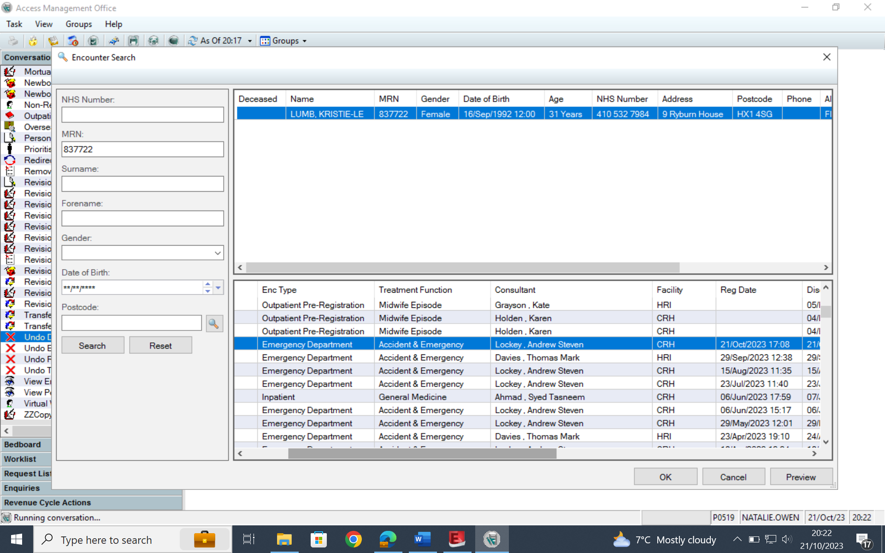

1. Select an appropriate **Room/Bay** and **Bed** from the drop-down menus. Select one of the Waiting Rooms or Triage for the Room/Bay and select any bed number.
2. Select **Return from Appointment** as the **Reason for Correction** and click **OK**.

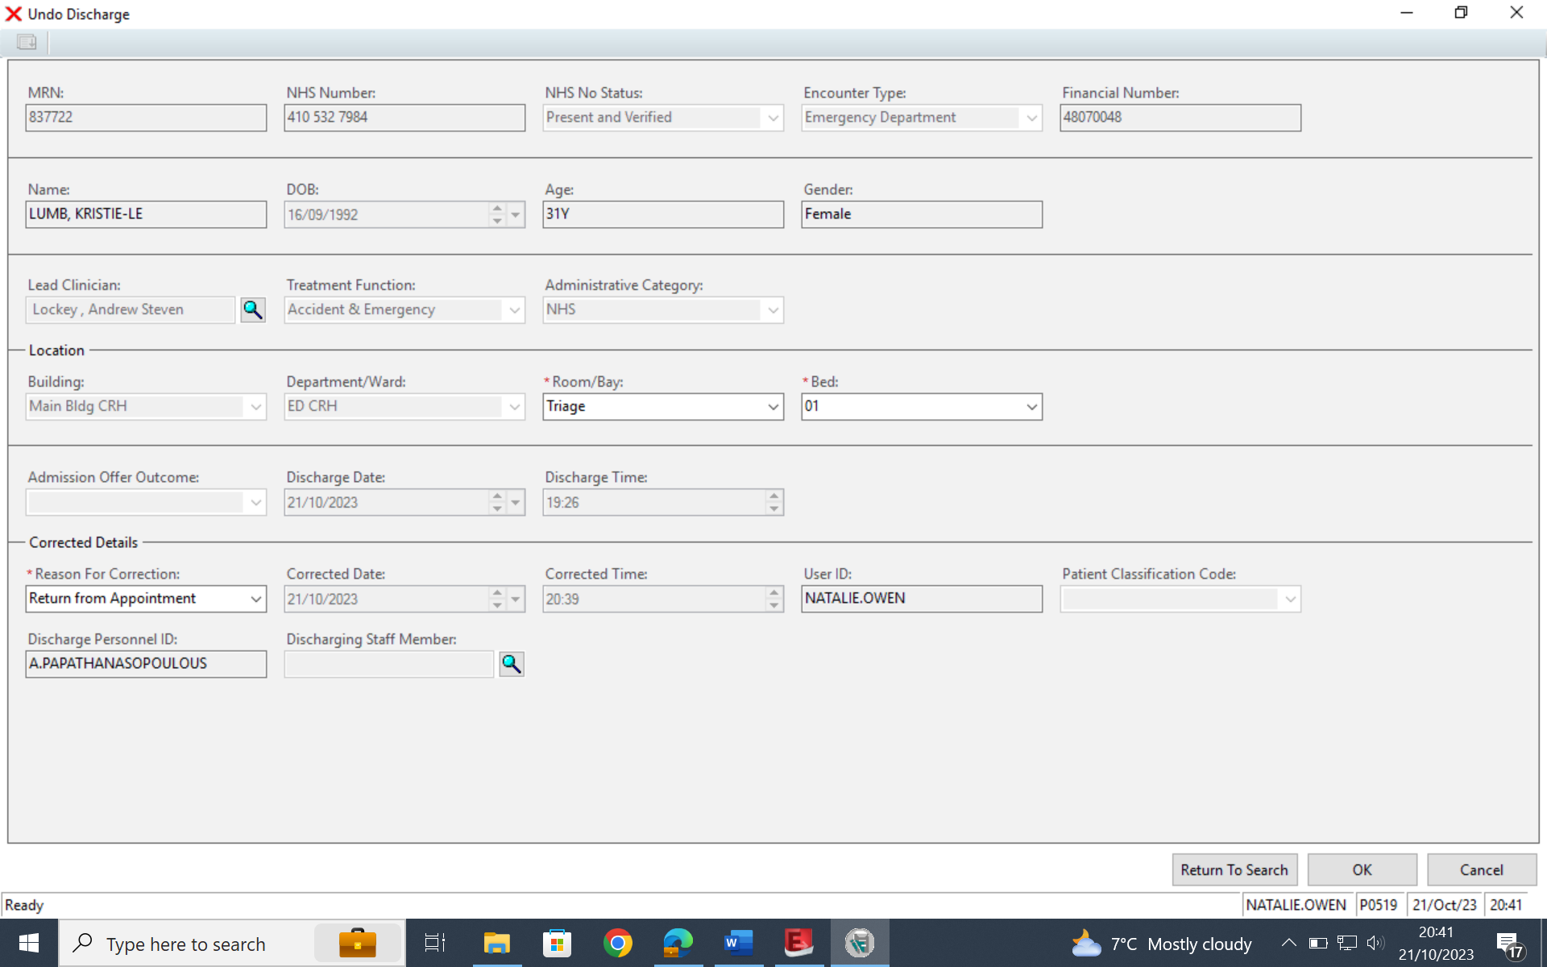

1. The discharge has now been undone and the patient will be back on the First Net screen. Change the **Location** to the appropriate **waiting room** and put a note in **Comments** to say **SENT BACK FROM LCD.**