**SMART CARD PROTOCOLS**

**SMART CARD EXPIRING**

For 90 days prior to expiry, you will receive a reminder every time you log in that your card is due to expire.

**You MUST renew your card BEFORE it expires – once your card has expired you will not be able to self-renew and your smartcard cannot be used.** If you have any problems renewing your smartcard, please contact Natalie, Tom or the Registration Authority.

**RENEW YOUR OWN SMARTCARD**

Using the smartcard you want to renew, [log in to Care Identity Management](https://manage-care-identities.care-identity-service2.nhs.uk/).

From the options available to you, select 'Renew your own smartcard'.

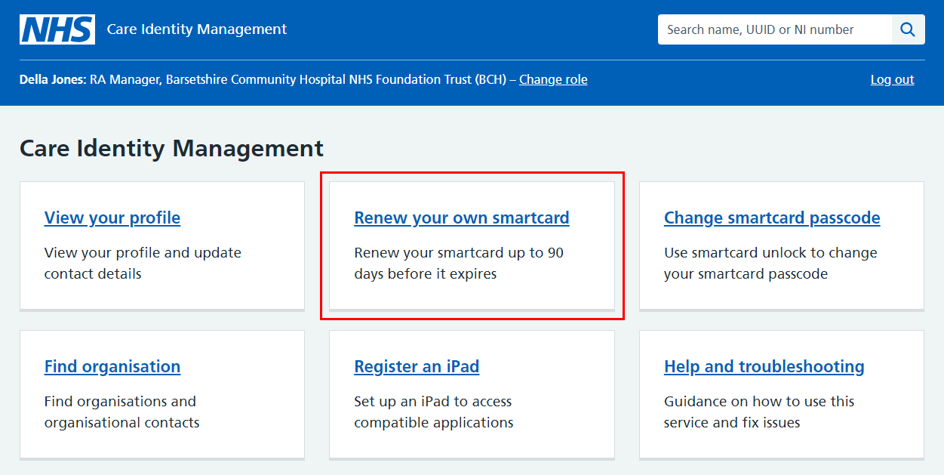

On the 'Renew smartcard certificates' screen, enter your passcode and select 'Continue'.

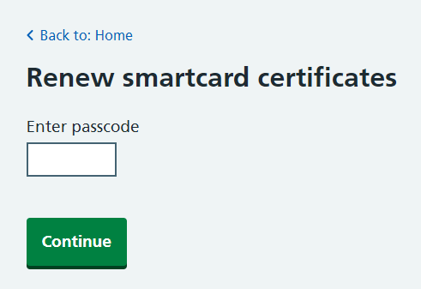

The service will now renew your certificates and you should see a message confirming the process has been successful.

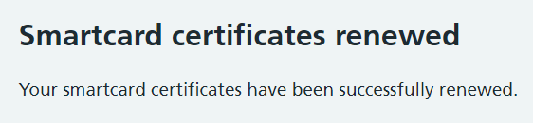

**SMART CARD LOCKED**

If you card is locked, you can unlock it yourself here: [Self Service Unlock Smartcard - Care Identity Management - NHS.UK](https://manage-care-identities.care-identity-service2.nhs.uk/#/self-service/unlock-authenticator) – follow the instructions on screen.

**ERROR MESSAGE WHEN INSERT SMART CARD**

If you get a red error message when putting your smart card into the reader

1. Restart your computer
2. Try your card in a different card reader to clarify if it is your card or the card reader that is the problem
3. If the reader is the problem – plug a separate reader in to use and report the reader that isn’t working
4. If the problem is your card, escalate this immediately to **Registration Authority**

**LOST SMART CARD**

You must report this to the **Registration Authority**

**ON SHIFT AND UNABLE TO USE YOUR SMART CARD**

***DO NOT USE ANOTHER COLLEAGUE’S SMARTCARD.***

1. Escalate the problem with your own Smartcard
2. Use **Emergency Smartcard** whilst unable to use yours, asking a **senior member of staff to sign it out** to you
3. **Do not take the Emergency card home**. Return it and sign it back in on log sheet.
4. The passcode for the Emergency smartcard is written on the log sheet.
5. CRH Emergency card is kept in the wall cupboard above the back desk in Reception
6. HRI Emergency card is kept in the cupboard at the NIC station in Majors.

**WHO TO ESCALATE PROBLEMS TO**

**During Office Hours:**

**Natalie Owen** – 07826 222531

**Tom Whittle** – 07795 911435

**Registration Authority** – Contact via IT Helpdesk or email [registration.authority@this.nhs.uk](mailto:registration.authority@this.nhs.uk)

**Out of Office Hours:**

**Clinical Site Matron** – Contact via Switch