**VICTIMS OF ASSAULT**

All patients who present to ED having been assaulted must be booked in with:

**Assault** as the **Reason for Visit** and

**Apparent Assault** selected as the **Incident Type.**

A **Victim of Assault form** must be completed with the patient after booking them in.

**NB** – the data from the Victim of Assault form is submitted anonymously – **the patients name and details are not disclosed.**

*The data is used to create intelligence for the West Yorkshire Violence Reduction group to use.*

1. After booking patient in, click onto **CRH** **ED All Patients** or **HRI ED All Patients** tab as appropriate.
2. Click on the patients' name to highlight it then click on the black **V** icon

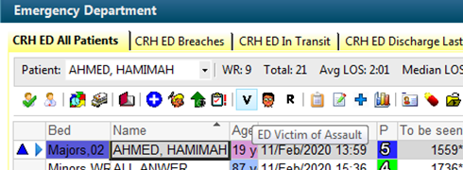

1. Complete all sections of the form with the patient, selecting appropriate tick box answers.
2. The **Name of location of assault** box requires you to **free type** the **specific location** the assault took place at.

For example – the name and location of the pub/club/shop/transport station etc where the assault happened. **Give as much detail as you can.**

1. Once finished, click the **green tick icon** in the top left corner

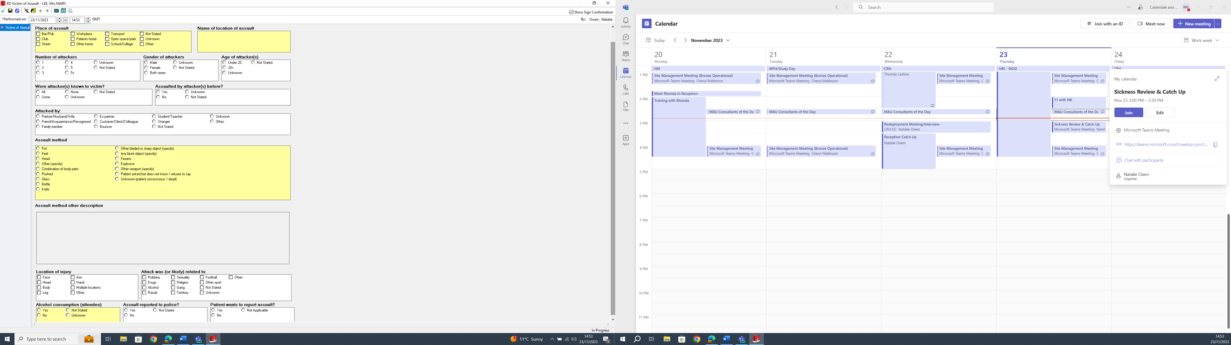

Free type full details of location of the assault here.