ED RECEPTION
How to Check In a Patient to an Outpatient Clinic

1 | In Schapptbook, open the appropriate clinic book from the Bookshelf
2 | Locate the patient’s appointment slot in the clinic book. It will be showing in purple as a confirmed appointment.
3 | Right click the appointment slot, select Actions then Check In  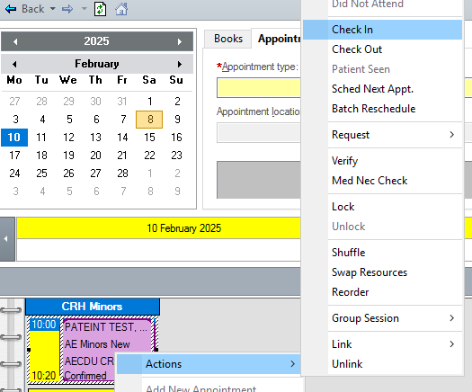
5 | Click OK to the next 2 windows that open
6 | Appointment should now change to green which means it has been checked in.  