ED RECEPTION
ENT Clinic Appointments SOP
1 | - Open Schapptbook, click on Books, double click Bookshelf and select CHFT – ENT  - Double click the red ENT Emergency book
2 | - Navigate the calendar to find the next available clinic slot.  - You must only use the CRH Emergency New or ACR Emergency New red clinic slots.  - Remember type of slot you have selected; you will need this when selecting Location.
3 | - Right click on desired clinic appointment slot, select Add New Appointment
4 | - Click blue square next to Appointment Type and select ENT New.
5 | - Click blue square next to Location and select either ENT CRH or Acre Mills.  - CRH clinic slot = ENT CRH Location  - ACR clinic slot = Acre Mills Location  - Ensure you select the correct location for the type of clinic slot you have chosen.
5 | - Click blue square next to Patient Name to open Patient Search window.  - Click Reset and enter the MRN to search for the patient
7 | - Click patient name to highlight it, click Add Encounter  - Select Yes when asked if it is a Waiting List Encounter.  - Select Outpatient Referral List from Conversation drop down menu
9 | - Right click anywhere on the list of episodes that appear and select Add Episode  - Click OK to 18 Week Wait Pathway when prompted.
10 | Double click on the episode you created (top of list with today’s date on), complete missing fields in the Referral window as below. Referral received date needs to be today’s date. 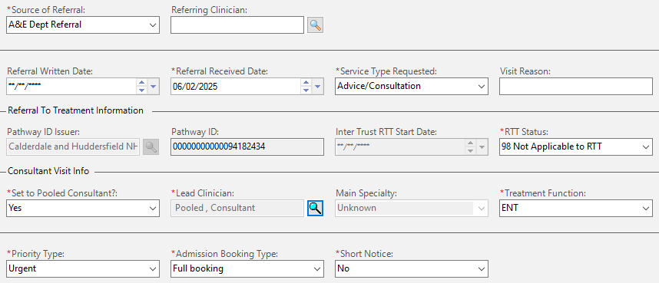
11 | - Click OK then OK again.  - Click Move, then Confirm. Select No for Send Letter to Print Services, click OK.
12 | - Print an appointment letter for patient. If patient is not present in department, post the letter or telephone patient to confirm appointment details.

