ED RECEPTION – A&E Minors Clinic Appointments SOP

Referred by Triage: Appt must be within 24 hours
If none available, inform Triage Nurse and patient must stay to be seen in dept

Referred by ENP/Doctor for follow up: Timescale as per Message Centre Request
If unable to meet requested timescale, book next available slot after requested date and inform the requesting clinician of the appointment delay.

1 | Open Schapptbook, click Books, double click Bookshelf, select CHFT – A&E, double click CHFT A&E – Minors book. You will see CRH Minors and HRI Minors Clinics as below.  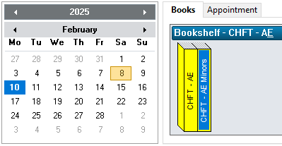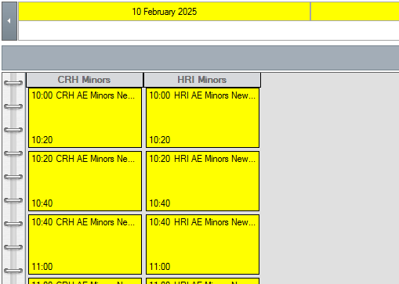
2 | Navigate calendar to select appropriate day, according to Triage Nurse/ENP request and ensuring for the correct site.
3 | Right click desired clinic appointment slot, select Add New Appointment
4 | Click blue square next to Appointment Type and select A&E Minors New
5 | Click blue square next to Patient Name to open Patient Search window.
6 | Click Reset and enter MRN to search for the patient
7 | Click patient name to highlight, click Add Encounter and Yes to Waiting List Encounter.
8 | Select Outpatient Referral List from Conversation drop down menu
9 | Right click on list of episodes, select Add Episode, click OK to 18 Week Wait Pathway
10 | Double click episode created (top of list with today’s date), complete missing fields in Referral window as below. Referral received date is today’s date.  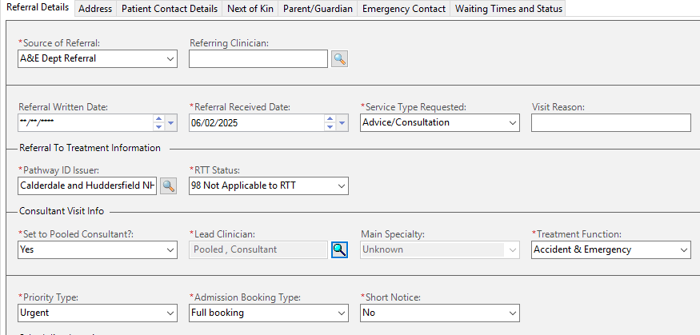
11 | Click OK and OK again. Click Move, then Confirm. Select No to Send Letter to Print Services and click OK.
12 | Print appointment letter for patient if they would like one.

