ED RECEPTION
Fracture Clinic – Patient Seen at Out of Area A&E SOP

- Patients who have attended a different A&E but need a Fracture Clinic appointment with us do not need to book into our A&E.

- Only book them into A&E if they need treatment from us. If they simply need a Fracture clinic appointment, follow the below SOP.

1 | - Take the patient’s details, locate their patient record and note their MRN.  - If they have not attended our Trust before and do not have an MRN, use the Add Person Without Encounter function to create one for them.
2 | Email a referral to the Appointment Centre Phones Team using the format below.  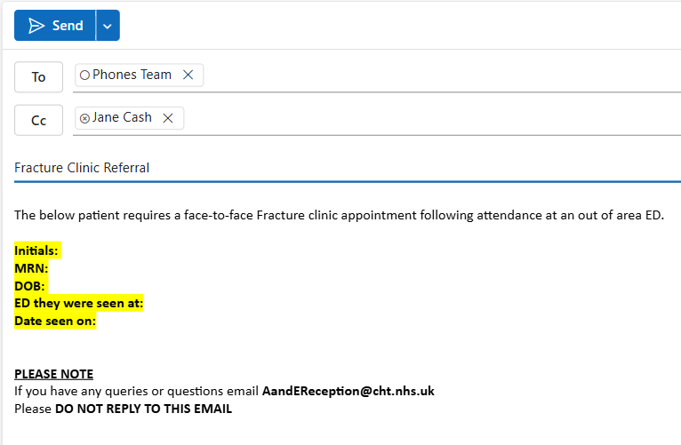
2 | The email addresses to send to are:  phones.team@cht.nhs.uk and  jane.cash@cht.nhs.uk
3 | Ensure that the information you enter is accurate.

