ED RECEPTION
Urology Clinic Appointments SOP

1 | Email a referral to the Urology Secretaries in the below format.  Email address to send to: urologysecs@cht.nhs.uk  The template for Urology referral emails can be found in the ED Reception Email Templates document on EMBEDS.  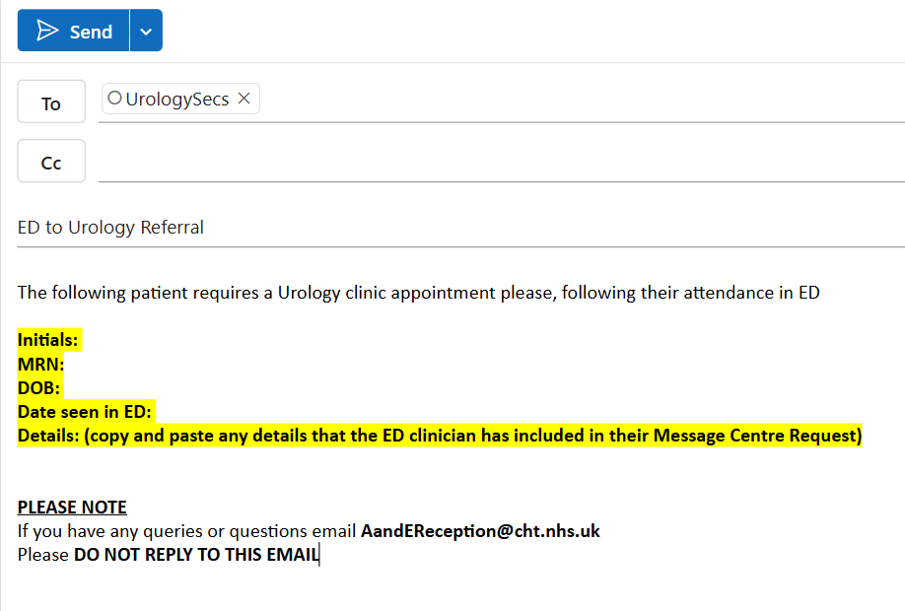
2 | Take care to ensure that you enter the required information (highlighted in yellow) accurately.

