ED RECEPTION
Virtual Fracture Clinic (VFC) Appointments SOP

PLEASE NOTE

VFC must always be booked for the next available slot (regardless of timescale clinician requests)

VFC appt must be within 3 calendar days of the A&E attendance (day of A&E attendance is Day 0)

If no VFC available within 3 days, do not book VFC appointment. See VFC – No Slots available SOP.

1 | - Open Schapptbook, click on Books, double click Bookshelf and select CHFT – T&O.  - Double click the white T&O Virtual Fracture book
2 | - Navigate the calendar to find the next available clinic slot, from the following day onwards – do not book into slots for the same day.
3 | - Right click on desired clinic appointment slot, select Add New Appointment
4 | - Click blue square next to Appointment Type and select T&O Virtual Trauma New
5 | - Click blue square next to Location and select HRI Main Out
6 | - Click blue square next to Patient Name to open Patient Search window.  - Click Reset and enter the MRN to search for the patient
7 | - Click patient name to highlight it, click Add Encounter  - Select Yes when asked if it is a Waiting List Encounter.  - Select Outpatient Referral List from Conversation drop down menu
8 | - Right click anywhere on the list of episodes that appear and select Add Episode  - Click OK to 18 Week Wait Pathway when prompted.
9 | Double click on the episode you created (top of list with today’s date on), complete missing fields in the Referral window as below. Referral received date needs to be today’s date.  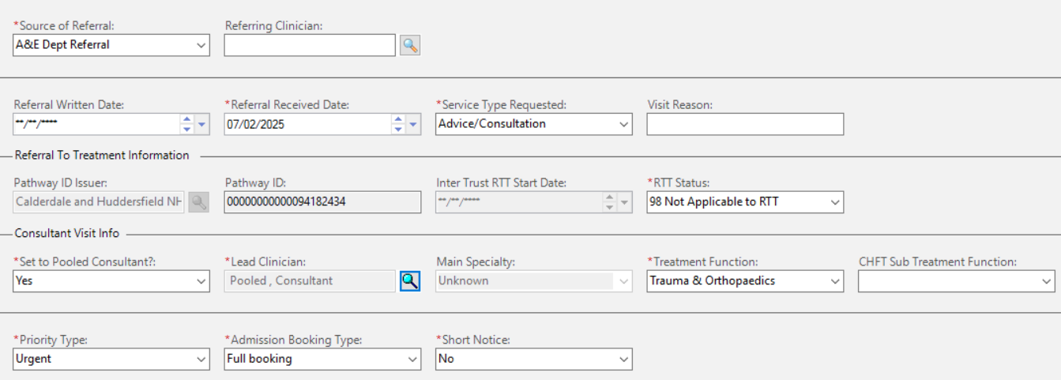
10 | - Click OK then OK again.  - Click Move, then Confirm. Select No for Send Letter to Print Services, click OK.

