ED RECEPTION
VFC - No Slots Available SOP

When a patient has been referred for VFC but there are no slots available within 3 calendar days, follow below protocol.

1 | Email a referral to the Appointment Centre Phones Team using the format below.  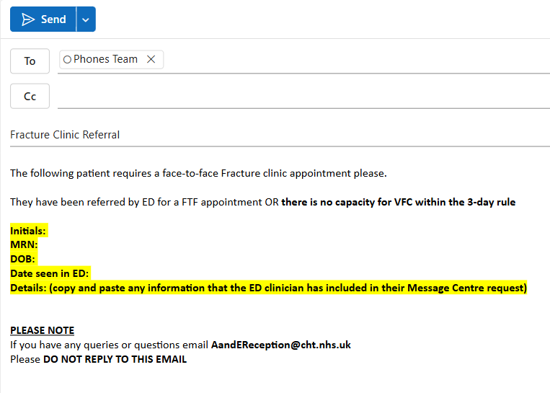
2 | The email address to send to is phones.team@cht.nhs.uk
3 | Ensure that the information you enter is accurate.

