ED RECEPTION
Eye Clinic Appointments SOP

1 | Email a referral to Eye Clinic in the below format.  The template for Eye Clinic referral emails can be found in the ED Reception Email Templates document on EMBEDS.  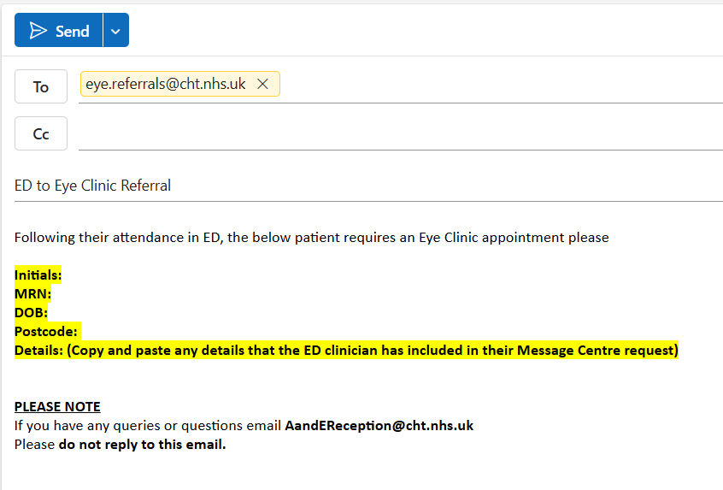
2 | Take care to ensure that you enter the required information (highlighted in yellow) accurately.

